**FPT ACADEMY INTERNATIONAL**

## FPT – APTECH COMPUTER EDUCATION





| **Center Name** | | FPT – Aptech – HCM2  Address: 590 Cach Mang Thang Tam, District 3, Ho Chi Minh City | |
| --- | --- | --- | --- |
| **Instructor** |  | Ms. Le Mong Thuy |  |
| **Class** |  | T1.2208.A0 |  |
| **Group** |  | 1 |  |
| **Group members** | | **Name** | **Student ID** |
|  |  | Co Trinh Hien Tai | Student1387819 |
|  |  | Nguyen Quang Hao | Student1408036 |
|  |  | Ho Vi Khang  Cao Van Chien | Student1408040  Student1408030 |
| **Duration** | Start date | 14th November 2022 |  |
| End date | 14th December 2022 |  |

**This is to certify that**

**Mr.:**

Co Trinh Hien Tai

Nguyen Quang Hao

Ho Vi Khang

**has successfully designed & developed**

eProject: Patrona website

**Submitted by:**

Co Trinh Hien Tai

**Date of issue:**

**Authorized Signature:**

**TABLE OF CONTENTS**

***FPT – APTECH COMPUTER EDUCATION***

***TABLE OF CONTENTS*** ***2***

***ACKNOWLEGMENT*** ***3***

***SYNOSIS*** ***3***

***PROBLEM DEFINITION*** ***3***

***CUSTOMER'S REQUIREMENTS SPECIFICATIONS (CRS)***

***Business/Project Objective*** ***4***

***Hardware/ Software Requirements*** ***5***

***SCOPE OF THE WORK (IN BRIEF)***

***Architecture and design of the system***

***Diagram of the website***

***TASK SHEET REVIEW 1***

***SITE MAP 10***

***MOCK OF THE WEBSITE*** ***1***

***1. Home*** ***1***

***2. Dogs*** ***2***

***3. Other Animals*** ***3***

***4. Nutrition 1******4***

***5. Gallery*** ***5***

***6. About Us*** ***6***

***7. Contact Us*** ***7***

***TASK SHEET REVIEW 2 18***

***WEBSITE DESCRIPTION*** ***9***

***RESPONSIVE*** ***28***

***JAVASCRIPT DESCRIPTION*** ***30***

***TASK SHEET REVIEW 3*** ***47***

# ACKNOWLEGMENT

On behalf of team members. I would like to thank everyone who supported my team to successfully complete this eProject report. Especially, our teacher, she has supported us a lot since we started studying at FPT Aptech. With this eProject, she guided us very meticulously, enthusiastically and strictly. With her guidance, we were able to successfully complete this project. Besides, I also want to thank all the team members, each of whom worked hard to complete the eProject in earnest during the month of working together. Finally, our group would like to say thank you to my classmates and family for sharing and creating for the group the best environment to focus on the project, motivating the members to achieve their goals.

# SYNOSIS

# The goal of the eProject is that we need to create a website that meets all the requirements of the client, Harvel Electric. Harvel Electric is an energy company specializing in the supply of various electrical products. They always satisfy customers with professional staff with many years of experience. The main goal of this website is to reach customers who need the best quality electrical products for their home or company. In addition, the products have discounts and promotions for customers, especially the company also supports the direct installation of their products. Customer satisfaction is always the top goal of Harvel Electric.

# PROBLEM DEFINITION

The Web site is to be created based on the following requirements.

1) The Home Page should be created making use of Sections with a suitable logo

2) The site should display a menu which will contain the options for brief introduction about the various products available, location of the shop and any other information if required.

3) The information should be categorized according to different type of products like if a User wants to see only ‘FANS’ then he click on a Link/button/menu etc and he will see different type of FANS. Similarly for ‘GEYSERS’, ‘CFL’ and other products

4) When a user selects any product type, a list of products for that product type will be displayed.

5) A brief summary of features of individual products should be displayed on the Web Page along with the product but detailed Features should be stored in Individual Word documents which can be downloaded or viewed by the User who wishes to see the same.

6) Price List should be available for download.

7) There should be a “Contact Us” page which will have the Address of the Company and the mail address which when clicked will invoke the local mail client from where they can send an email. Address of the Company should be displayed using GeoLocation API (eg. GoogleMaps).

# CUSTOMER'S REQUIREMENTS SPECIFICATIONS (CRS)

**Client: Patrona**

### Business/Project Objective:

The PATRONA puppy website is a website which is actually encyclopedia about all types of dogs. The Famous Veteran Patrona is fond of animals especially Dogs, Cats,Rabbits. With her achievements in the field of serving as veteran, she also had interest in writing books on animals and their behavior. All those years she had came across various type of breeds and their characteristics and behavior. Due to passion of photography she has a huge collection of animal pictures of all types discovered.Ms Patrona wish to share this images with all for which she had decided to develop a website of various animals. A Website on Dogs was proposed to be developed which will show all the types of dogs found in which location, their behavior, characteristics and so on. The website developed must have the arrangement of the animal’s country wise,type wise, breed wise. The website is to be developed for the Windows Platform using HTML5, JavaScriptand Geolocation. The site should work well in all leading browsers including Chrome,IE,FireFox etc.

**Input to the system:**

- Sorting by country, type.

- Searching by location, behavior, characteristics.

- Register members on the website.

**Output from the system:**

-Navigation bar contains Dogs, Food & Nutrition, Gallery, Login.

- Display information about the dogs and puppies such as: location, behavior, characteristics.

- Display the result when the request is executed.

- User can know more about them(Dogs and Puppies) by the way click on the letter “More details”

- Not only display information about dogs and puppies but also about the other animals on the navigation bar.

-Display each dogs informations and images when clicking on each photo on the home page(content scope).

- Display each individual's feedback when clicking on each photo on the feedback scope.

- Moreover, Food and Nutrition tips are also mentioned to satisfy user’s questions.

- Display enjoyable images of dogs .

- Query link available on the footer to help users know more about the page.

- Contact us contains address, phone number and online map.

- Storage user information to make the following access easier.

**Process**:

* + - * Validate data input from users.

**Expected delivery date:** 22-July-2020.

**List of deliverables:**

- Document Word, PDF.

- User Guide.

- Source code.

### Hardware/ Software Requirements:

* **For developer**

**Hardware**

* + Intel Pentium 4 processor or higher
  + 01 Gigabytes of RAM or higher

**Software**

* + Windows 7 OS or higher
  + Adobe Dreamweaver
  + Web browsers such as IE, Chrome or Firefox are supporting HTML5, CSS3 and angularJS.
* **For web users**

**Hardware**

* + Intel Pentium 4 processor or higher
  + 512 Megabytes of RAM or higher

**Software**

* + Windows XP OS or higher
  + Web browsers such as IE, Chrome or Firefox are supporting HTML5, CSS3 and angularJS.

# SCOPE OF THE WORK (IN BRIEF)

After a long and detailed discussion, our group has decided to create a website contain the following webpages:

1. Home: Introduction to the site, the members of the group.
2. Dogs: Display dog species, allowing users to view information about each dog species they want.
4. Nutrition & food: Display food, nutrition of different animals.
5. Gallery: Show pictures of dogs.
6. Ask: The questions will be listed on.
7. Sign in: Allow users to login to the website

# ARCHITECTURE AND DESIGN OF THE SYSTEM

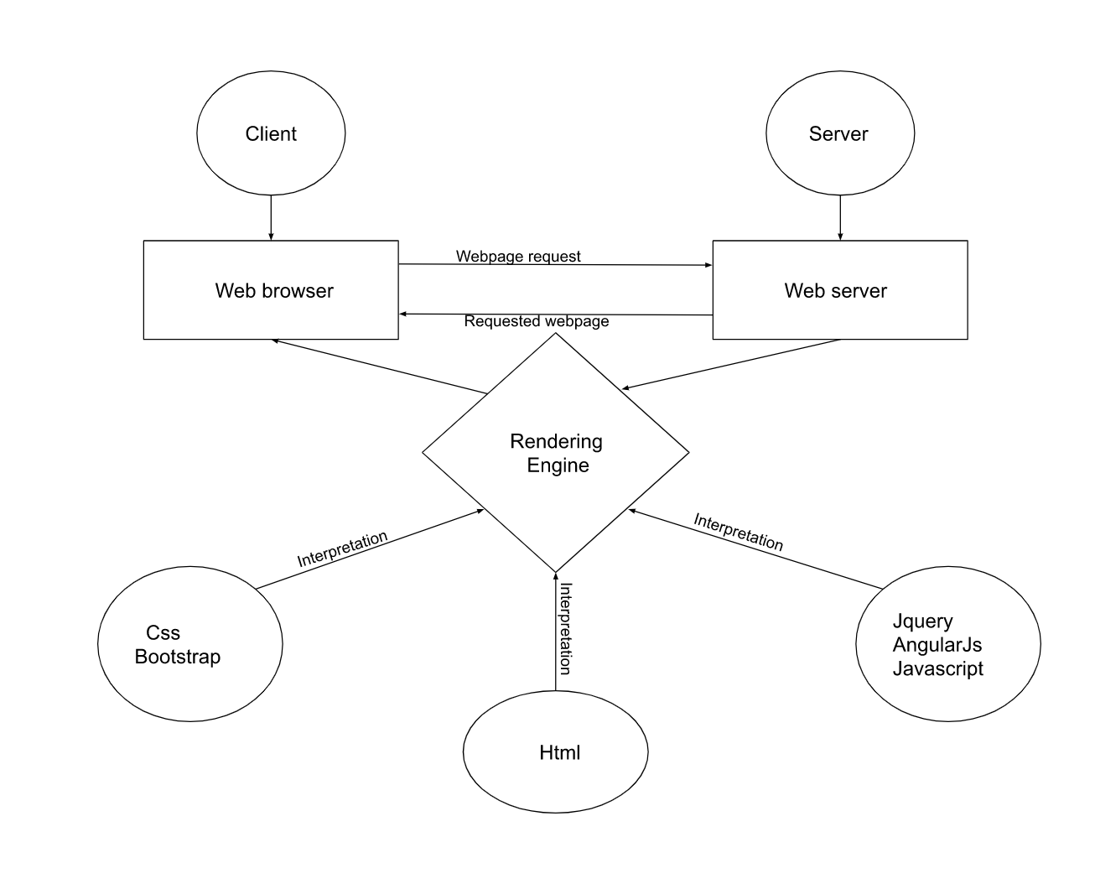

# DIAGRAM OF THE WEBSITE

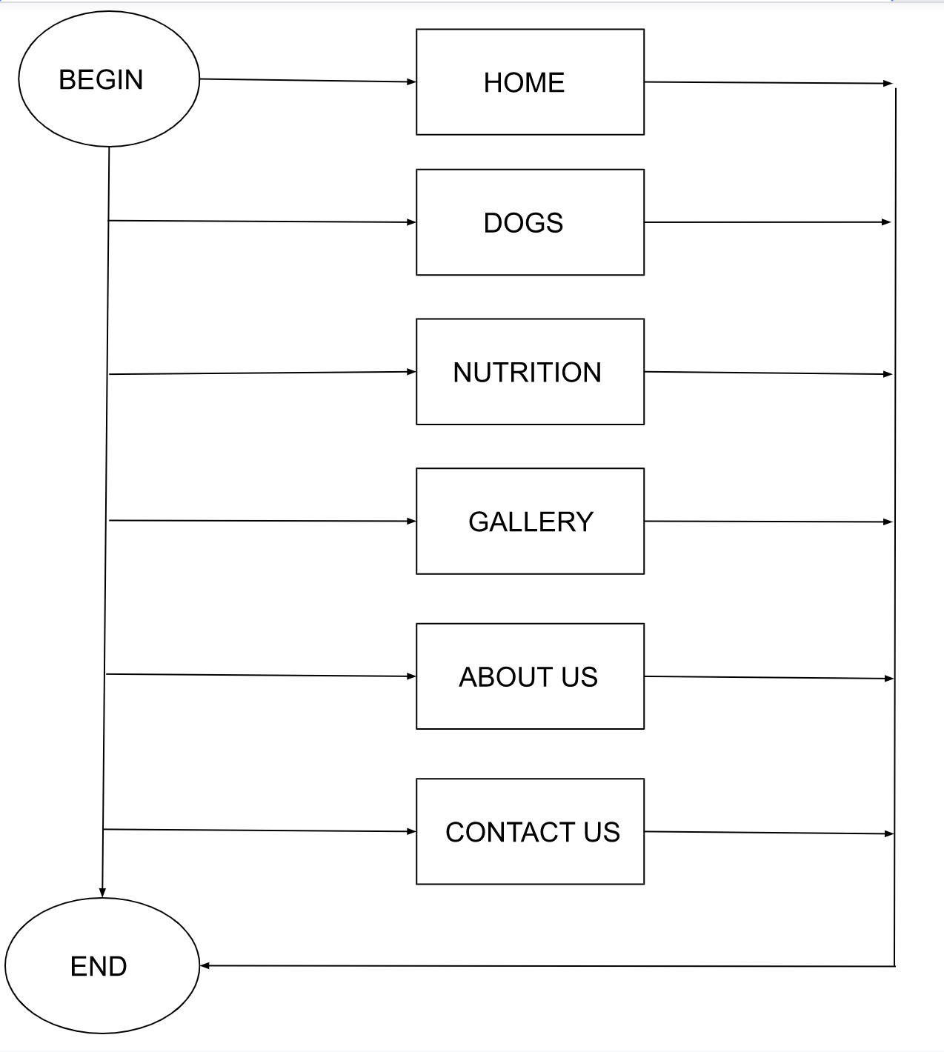



# TASK SHEET REVIEW 1

| **Project Ref. No.:**  **eP/Advertisement Portal Management**  **System/01** | | **Project Title:** | **Activity Plan Prepared By:** | **Date of Preparation of Activity Plan:** | | | |
| --- | --- | --- | --- | --- | --- | --- | --- |
| **Sr.**  **No.** | **Task** | **Actual**  **Start**  **Date** | **Actual Days** | **Team**  **Mate Names** | **Status** |
| 1 | Problem Statement | PATRONA | Tai | 14-November-21 | 1 | Khang | Completed |
| 2 | Analysis of Patrona requirements about the website | 14-November-21 | 1 | Tai | Completed |
| 3 | The scope of the work (in brief) | 14-November-21 | 1 | Hao | Completed |
| 4 | Architecture and design of the system | 14-November-21 | 1 | Chien | Completed |
| 5 | Diagram of the website | 14-November-21 | 1 | Chien | Completed |
| 6 | Task Sheet | 14-November-21 | 1 | Khang | Completed |

| **Date:** | |
| --- | --- |
| Signature of Instructor:  **Ms. Le Mong Thuy** | Signature of Team Leader:  **Co Trinh Hien Tai** |

# SITE MAP

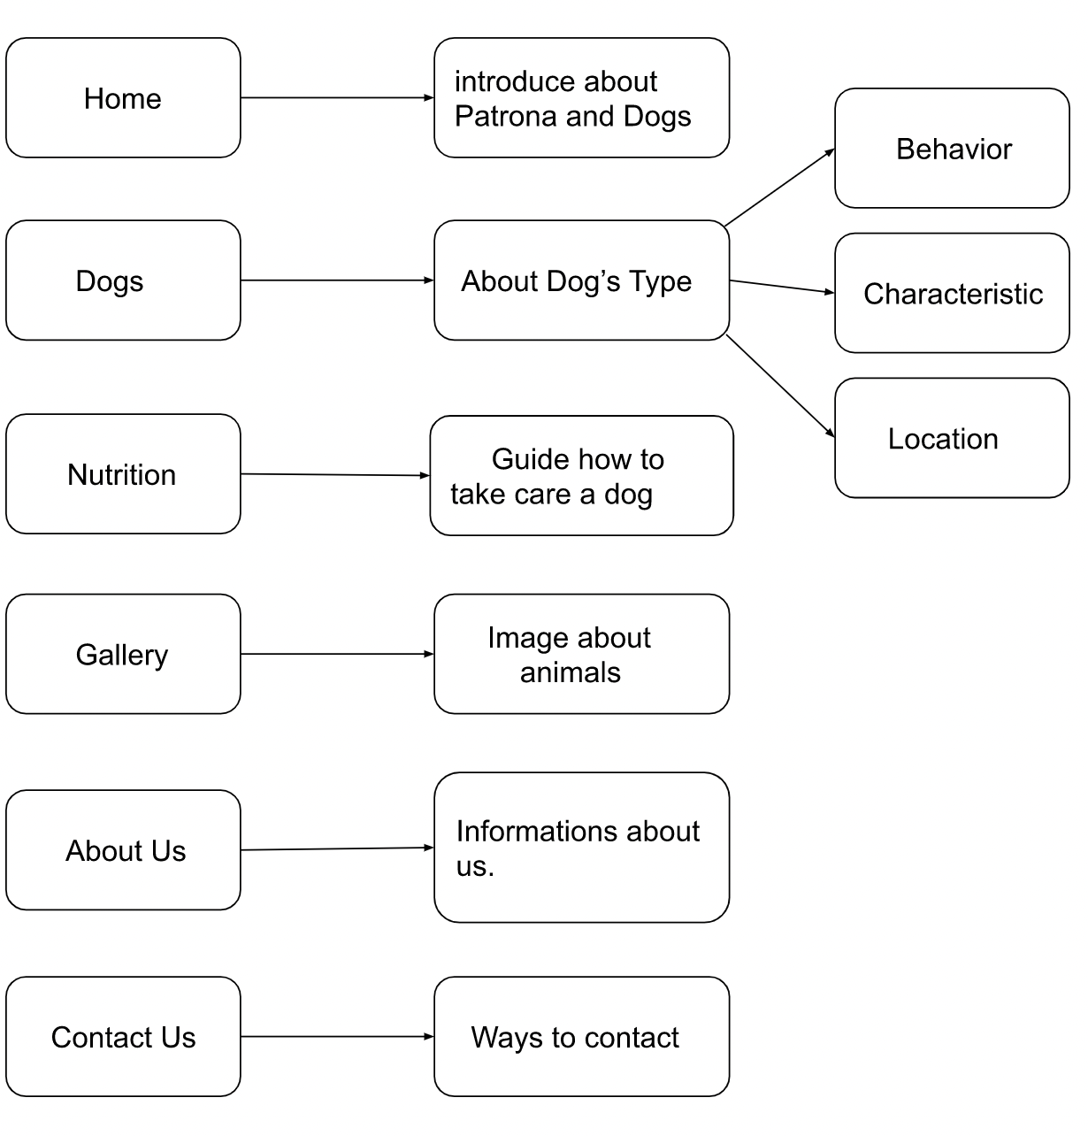

# MOCK OF THE WEB SITE

1. **Homepage**

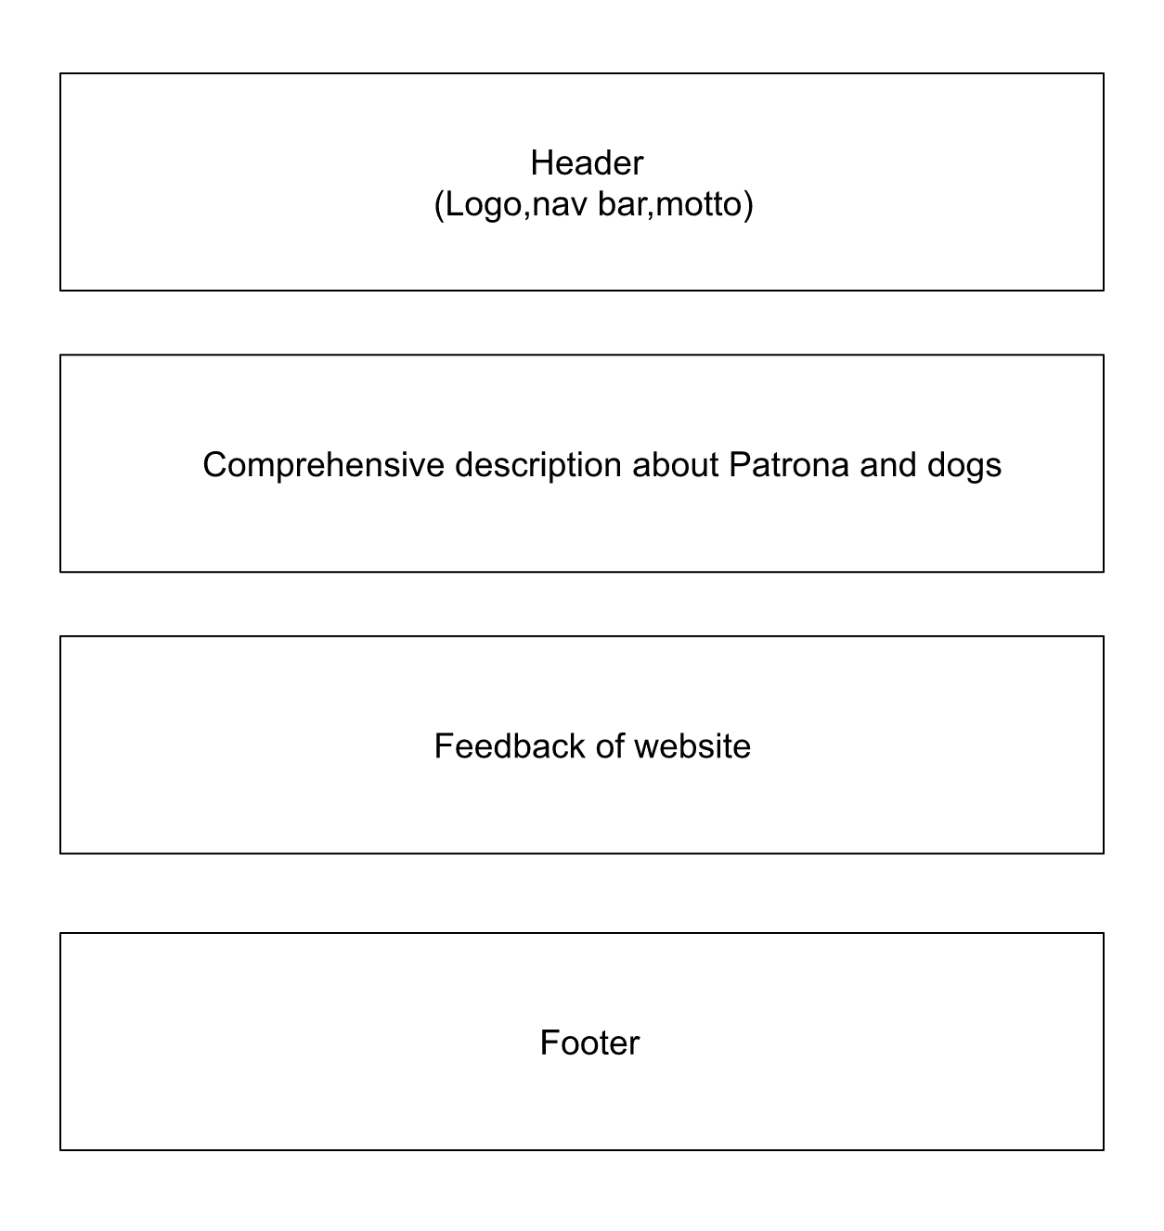

1. **Dogs**

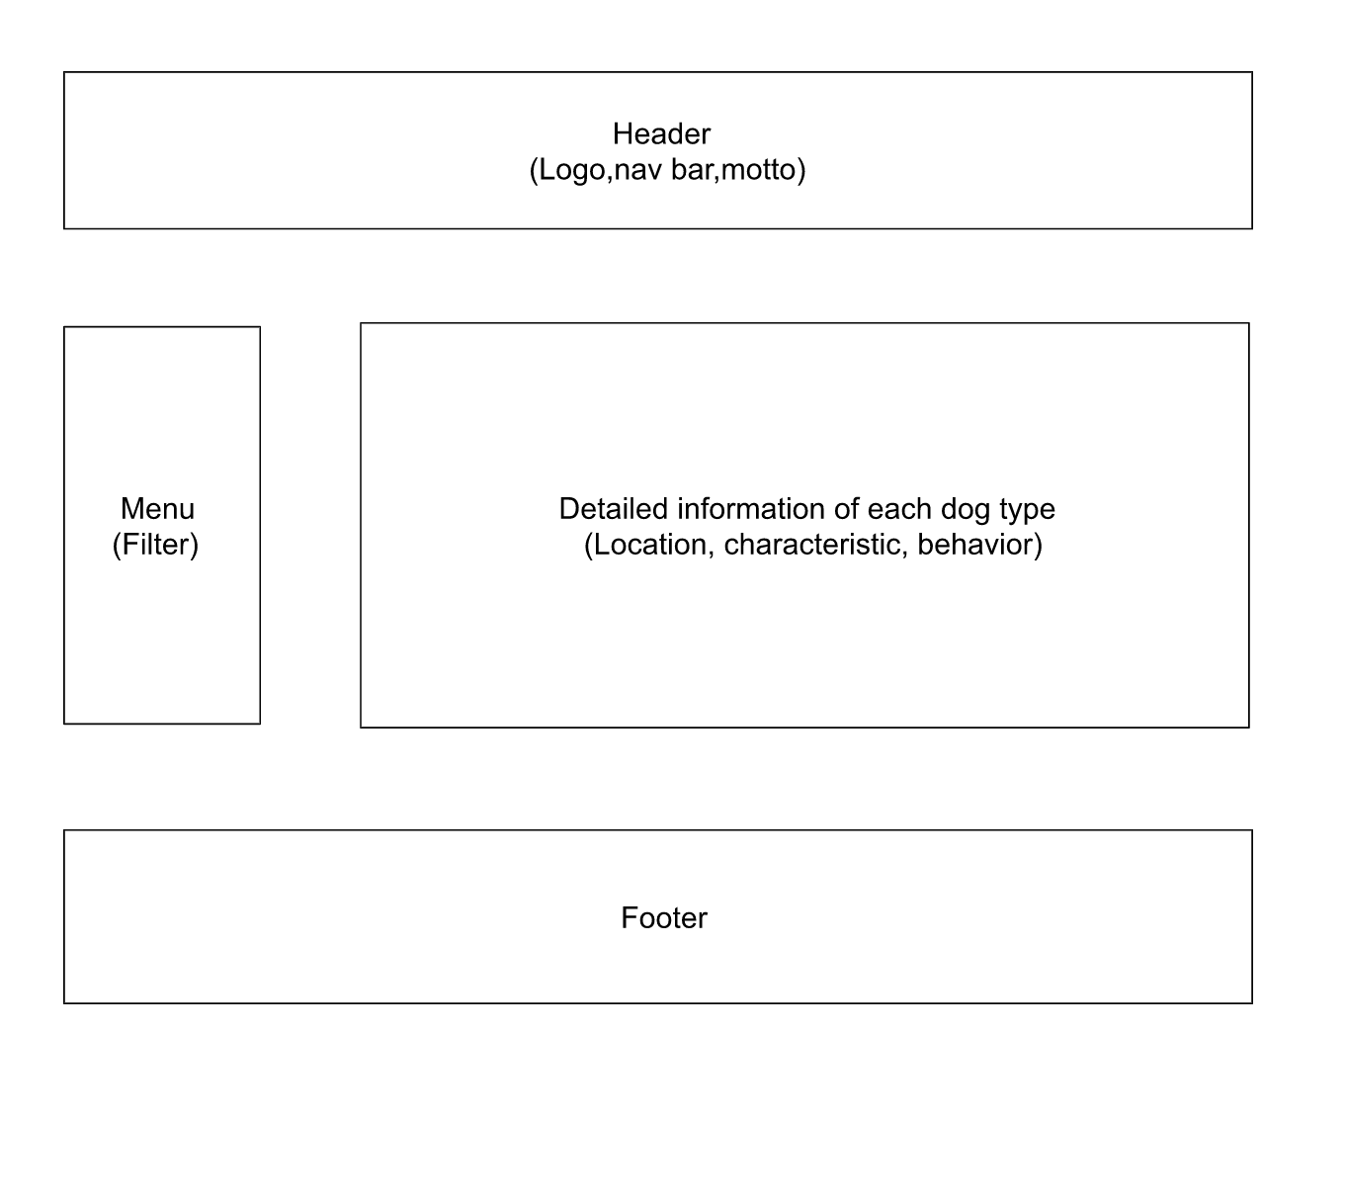

1. **Nutrition**

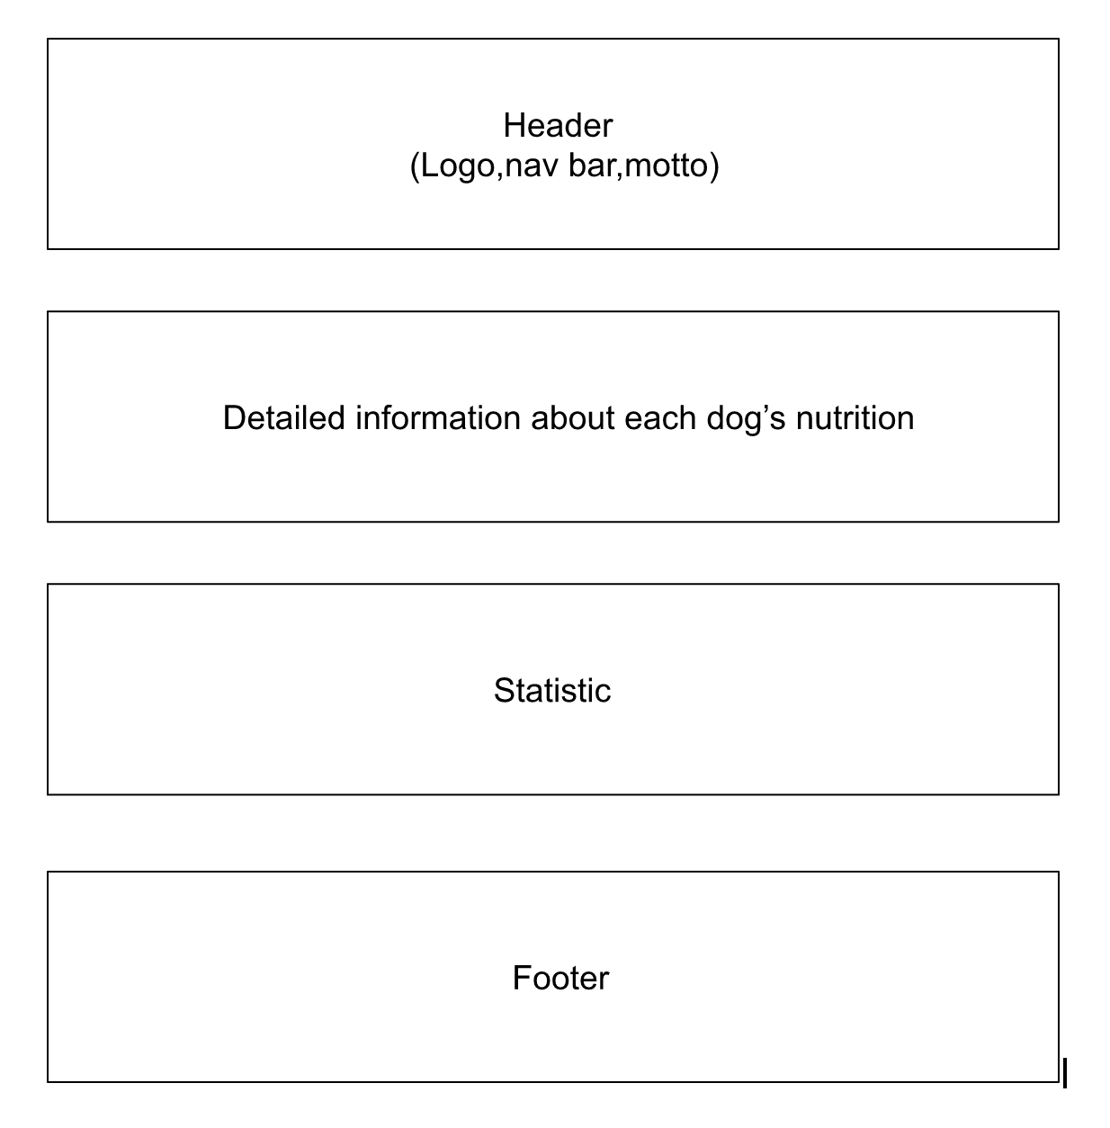

1. **Gallery**

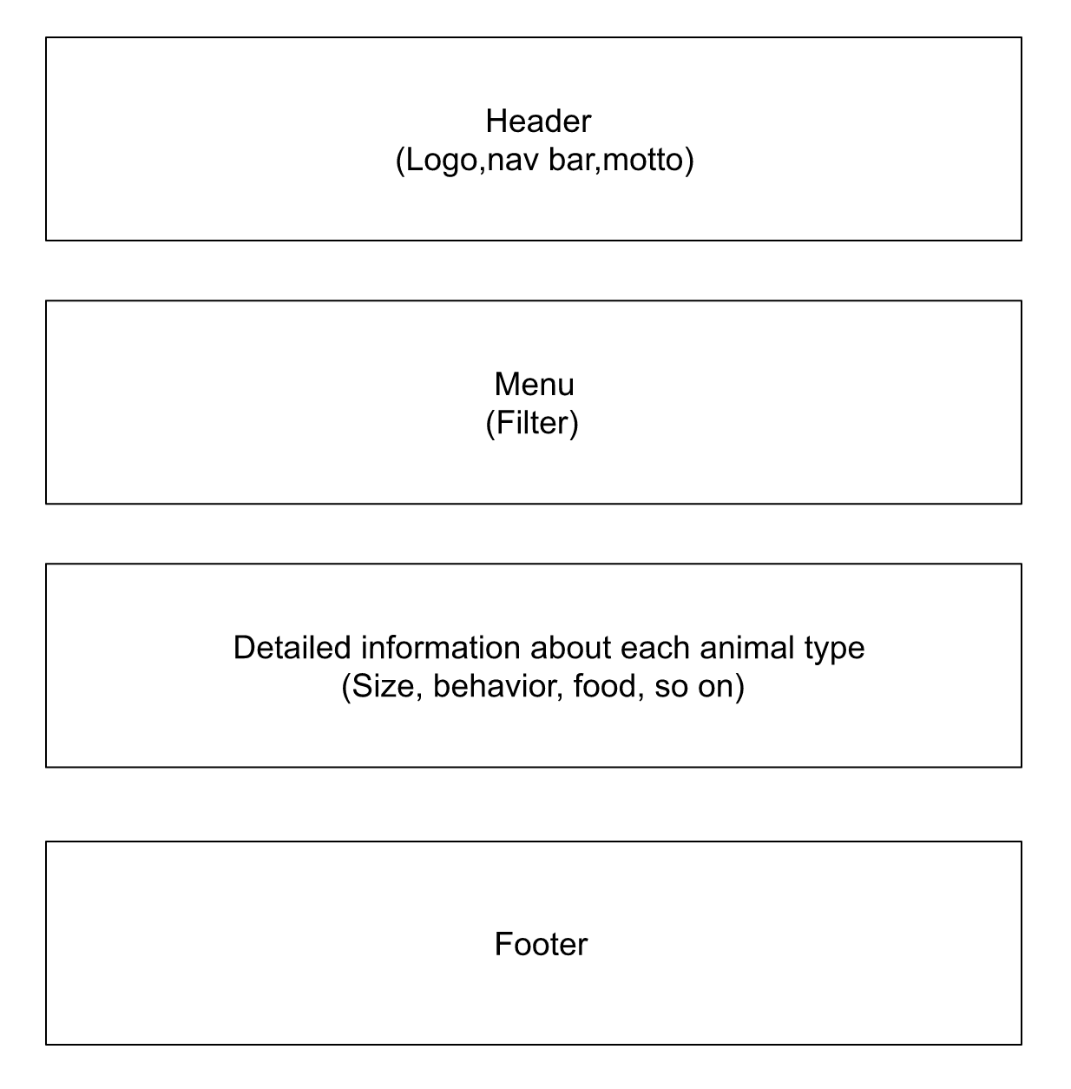

1. **About Us**

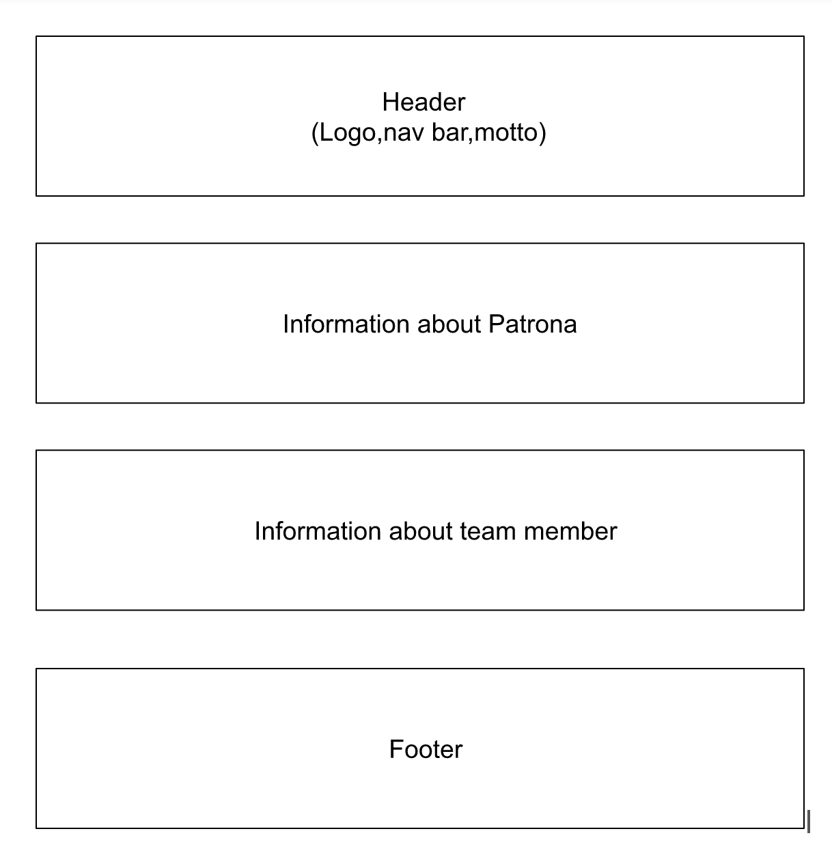

**6.Contact Us**

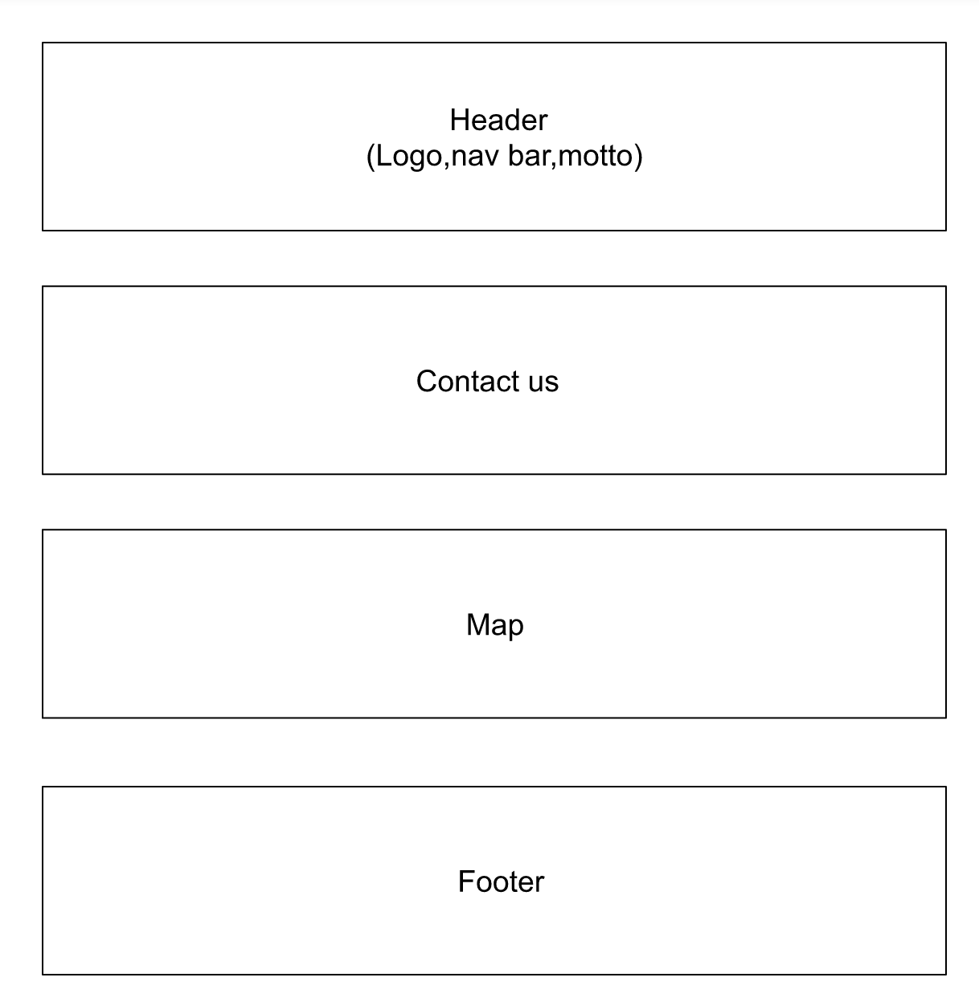

# 

# TASK SHEET REVIEW 2

| **Project Ref. No.:**  **eP/Advertisement Portal Management**  **System/01** | | **Project Title:** | **Activity Plan Prepared By:** | **Date of Preparation of Activity Plan:** | | | |
| --- | --- | --- | --- | --- | --- | --- | --- |
| **Sr.**  **No.** | **Task** | **Actual**  **Start**  **Date** | **Actual Days** | **Team**  **Mate Names** | **Status** |
| 1 | Site Map | PATRONA | Tai | 16-November-22 | 1 | Tai | Completed |
| 2 | Mock of the website | 16-November-22 | 1 | Khang,Chien | Completed |
| 3 | Task sheet | 16-November-22 | 1 | Hao | Completed |

| **Date:** | |
| --- | --- |
| Signature of Instructor:  **Ms. Le Mong Thuy** | Signature of Team Leader:  **Co Trinh Hien Tai** |

# WEBSITE DESCRIPTION

1. **Home**
2. Description

Home page displays following information:

- Navigation bar with six elements

- Patrona’s diary

- Informations about 3 type of dogs

- Feedback of the users

1. Screen shot

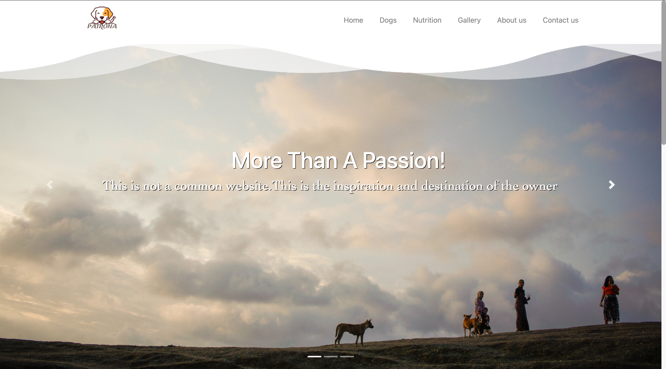

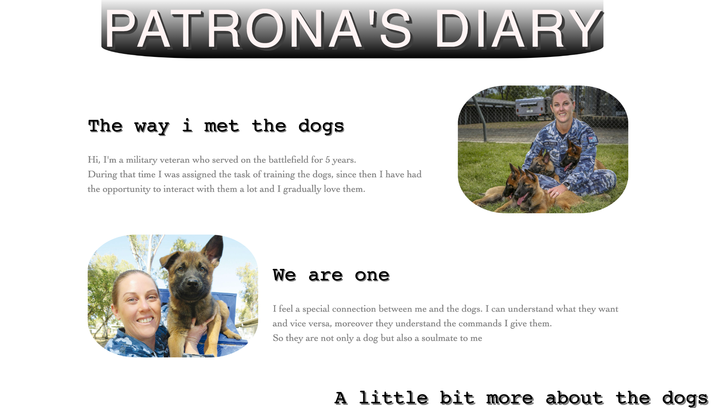

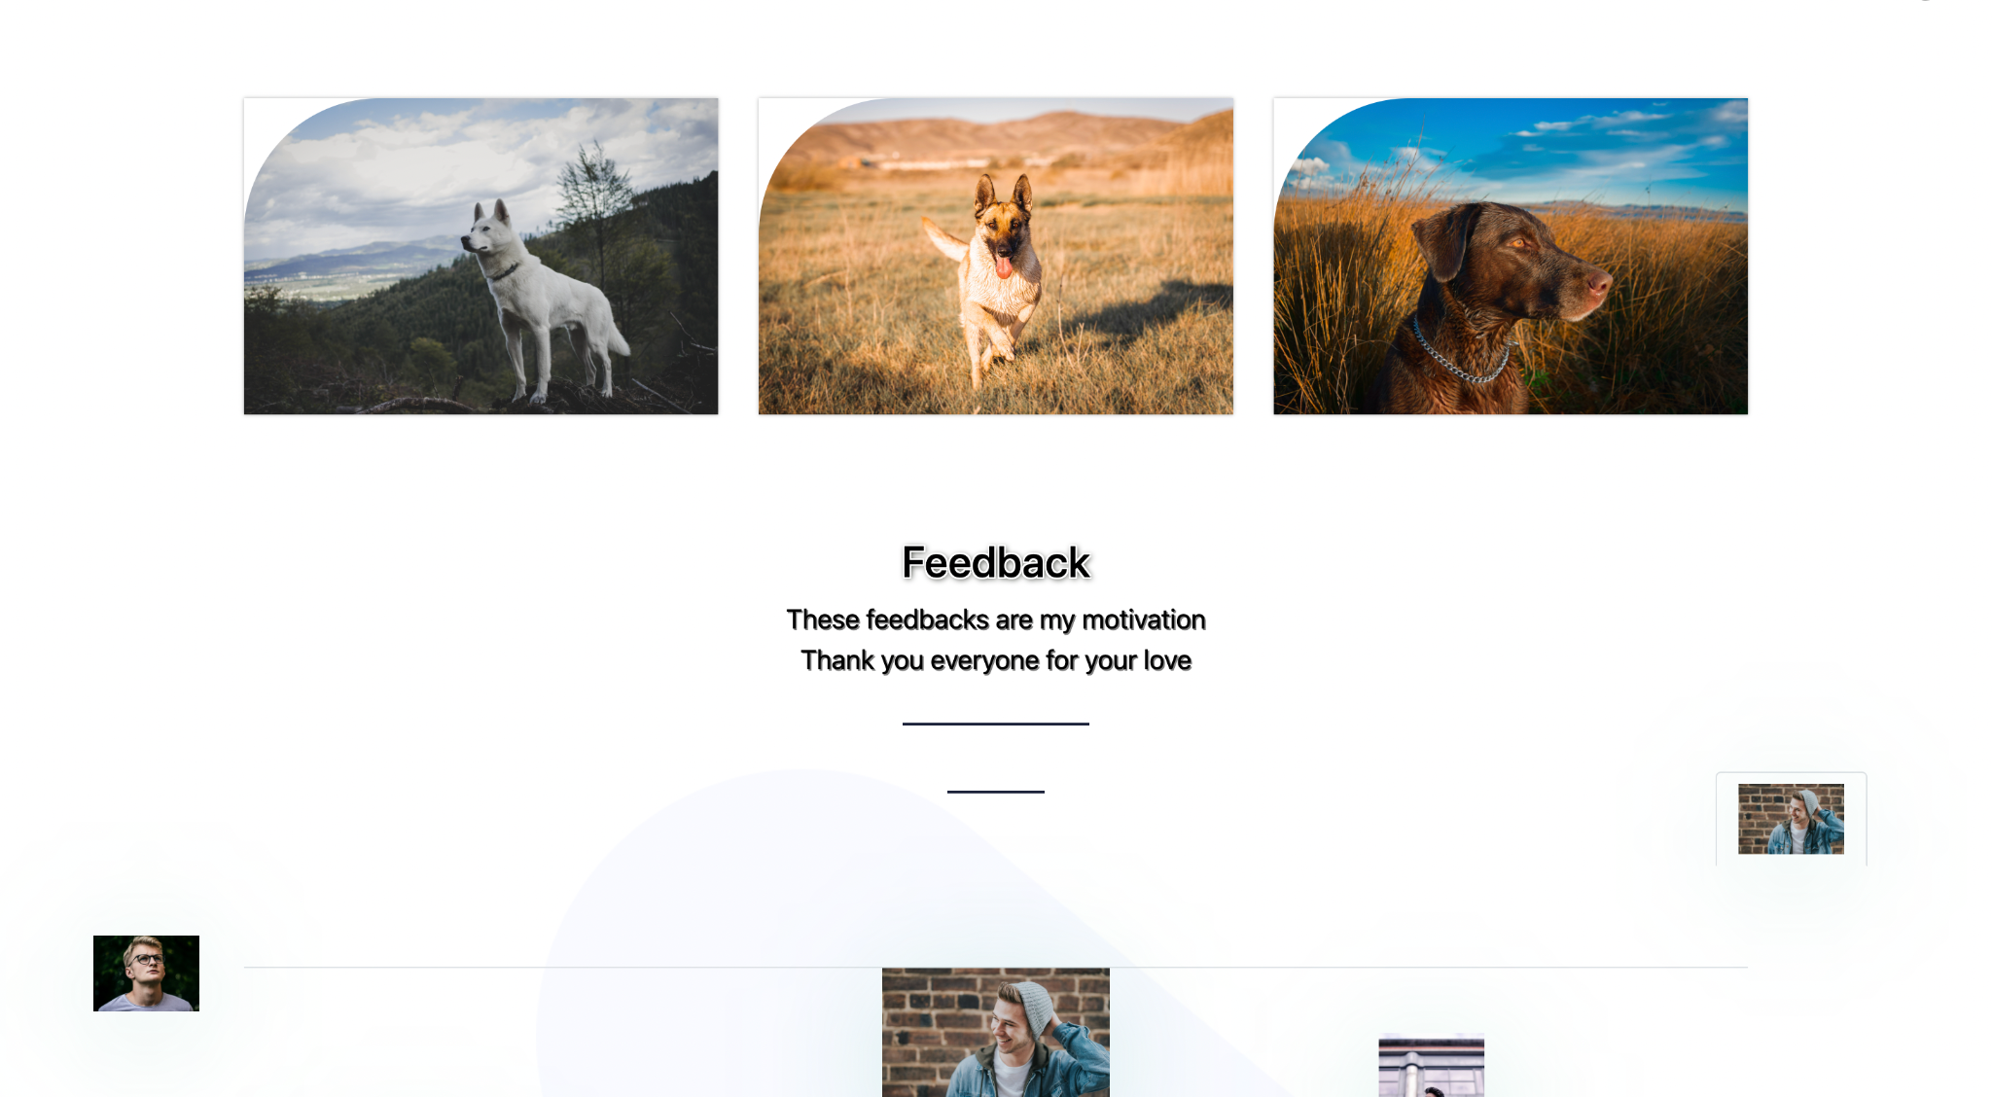

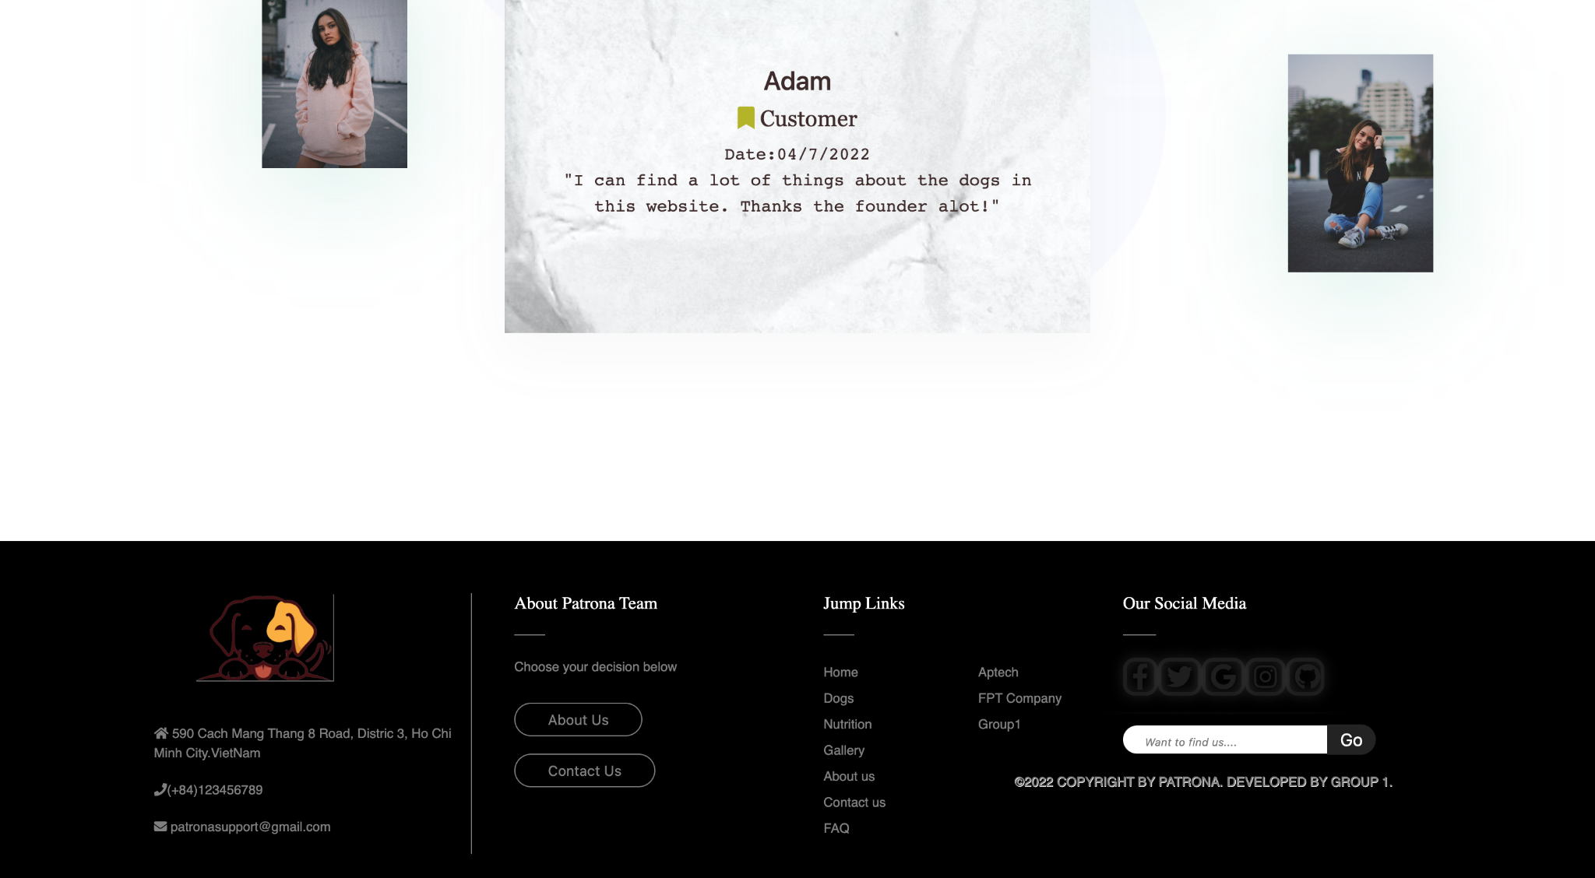

1. **Dogs**
2. Description

- This site could satisfy the user’s answers, because it contains a lot of information about dogs like: characteristics, behavior, location, and so on.

- The Filter area can be sorted by some characteristics(color, size,..) of dogs.

- Read more letter can lead users to the other site containing more information about each dog.

- Product can sort by price and by name.

1. Screen shot

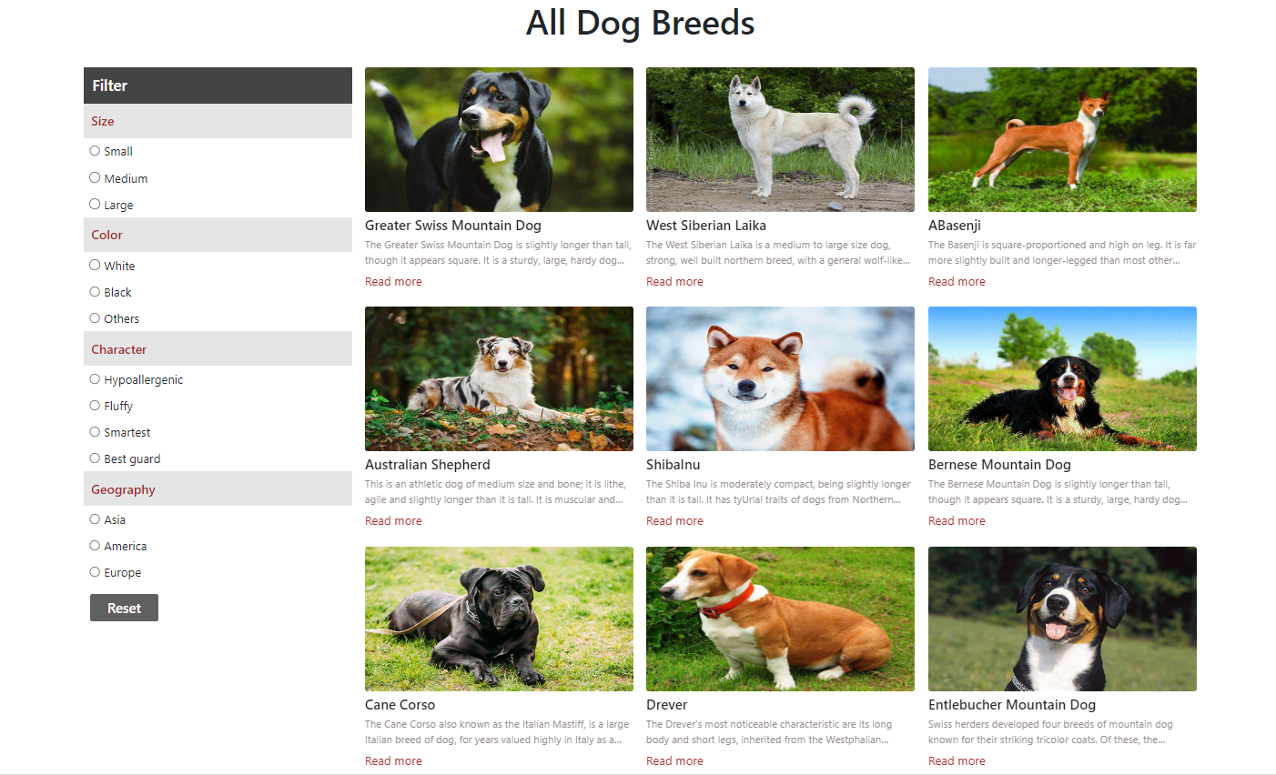

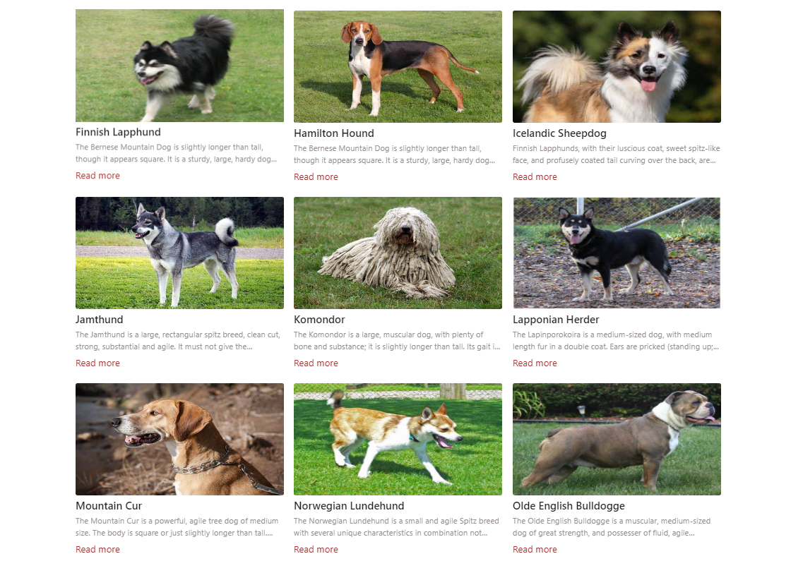

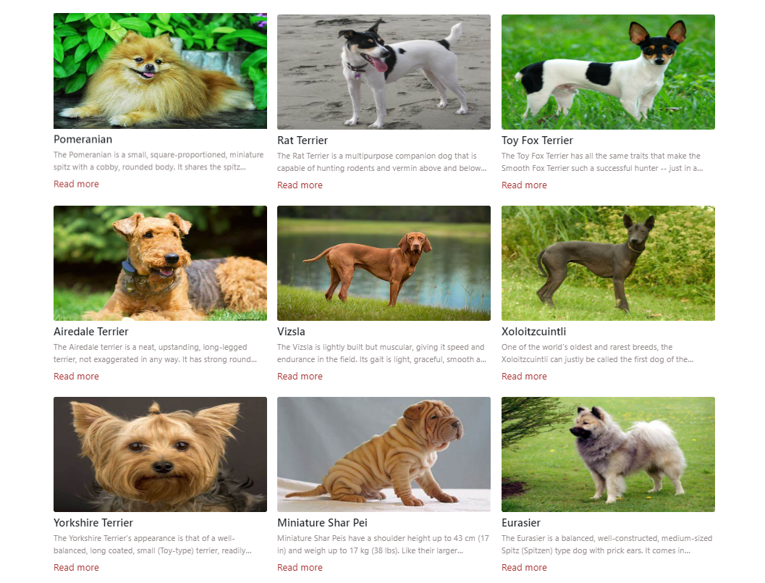

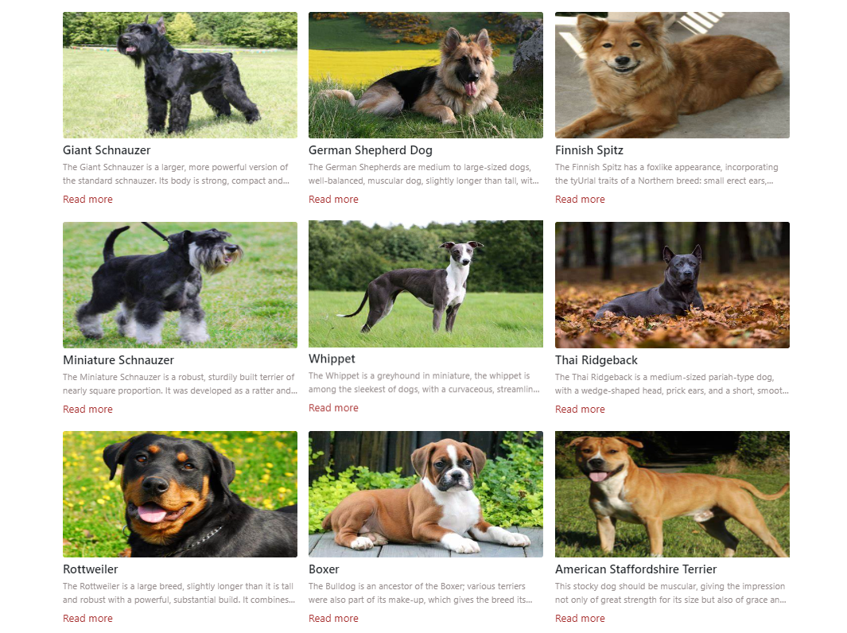

1. **Nutrition**
2. Description

Three core nutritions mentioned on this site such as:

- Nutrients your dog needs.

- Weaning and feeding your puppy.

- Feeding your adult dog.

1. Screen shot

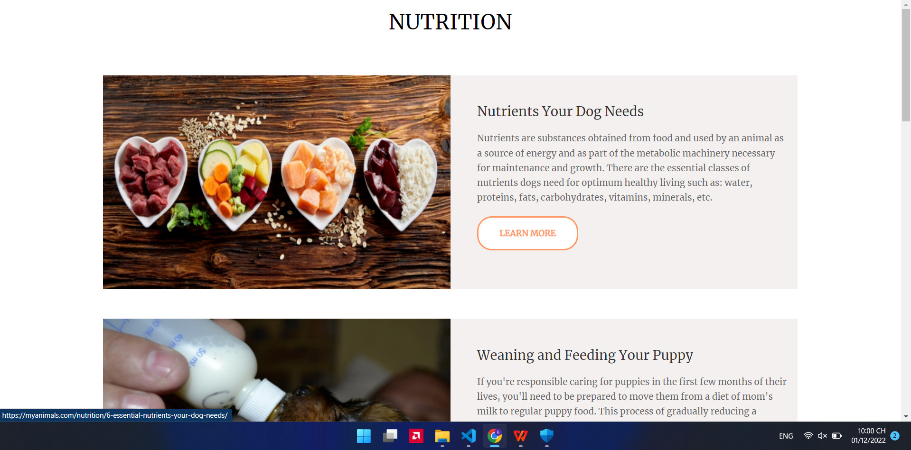

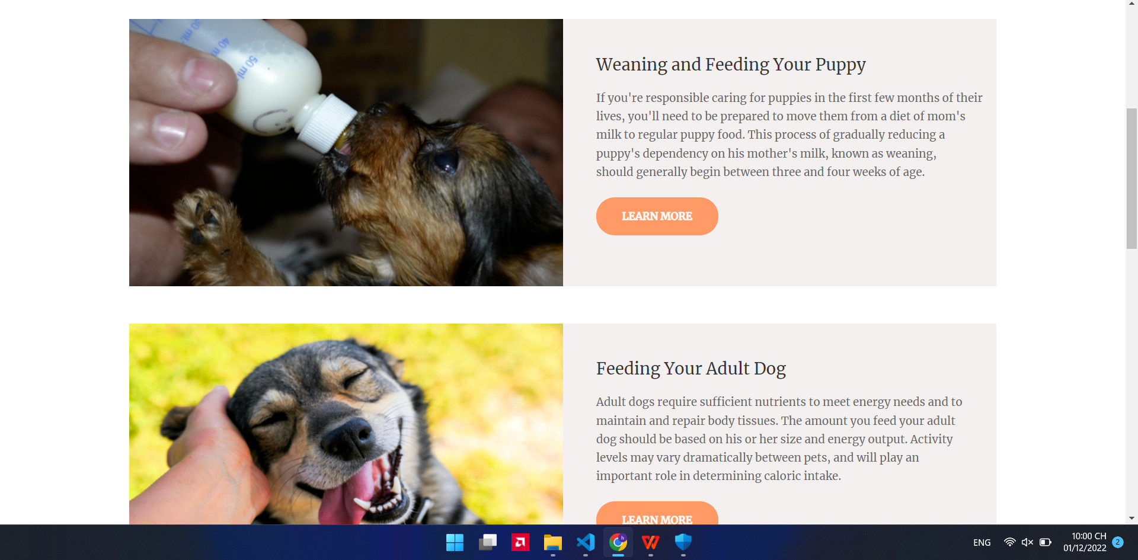

1. **Gallery**
2. Description

- This site shows a large number of dog’s images based on their size(big,small or medium).

- Moreover it can be sorted by the buttons on the top.

1. Screen shot

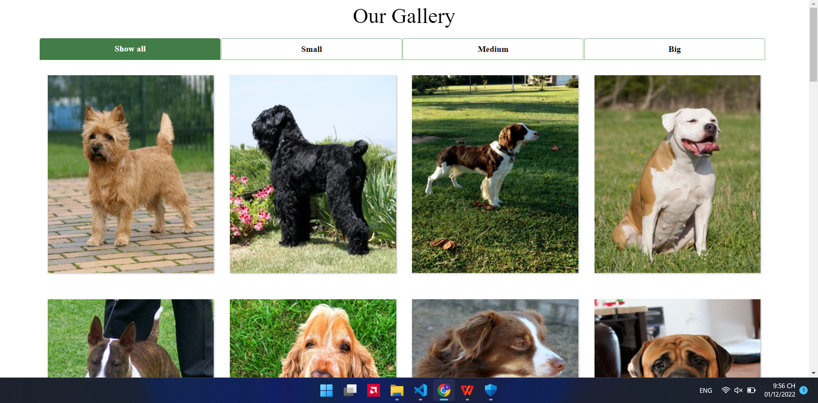

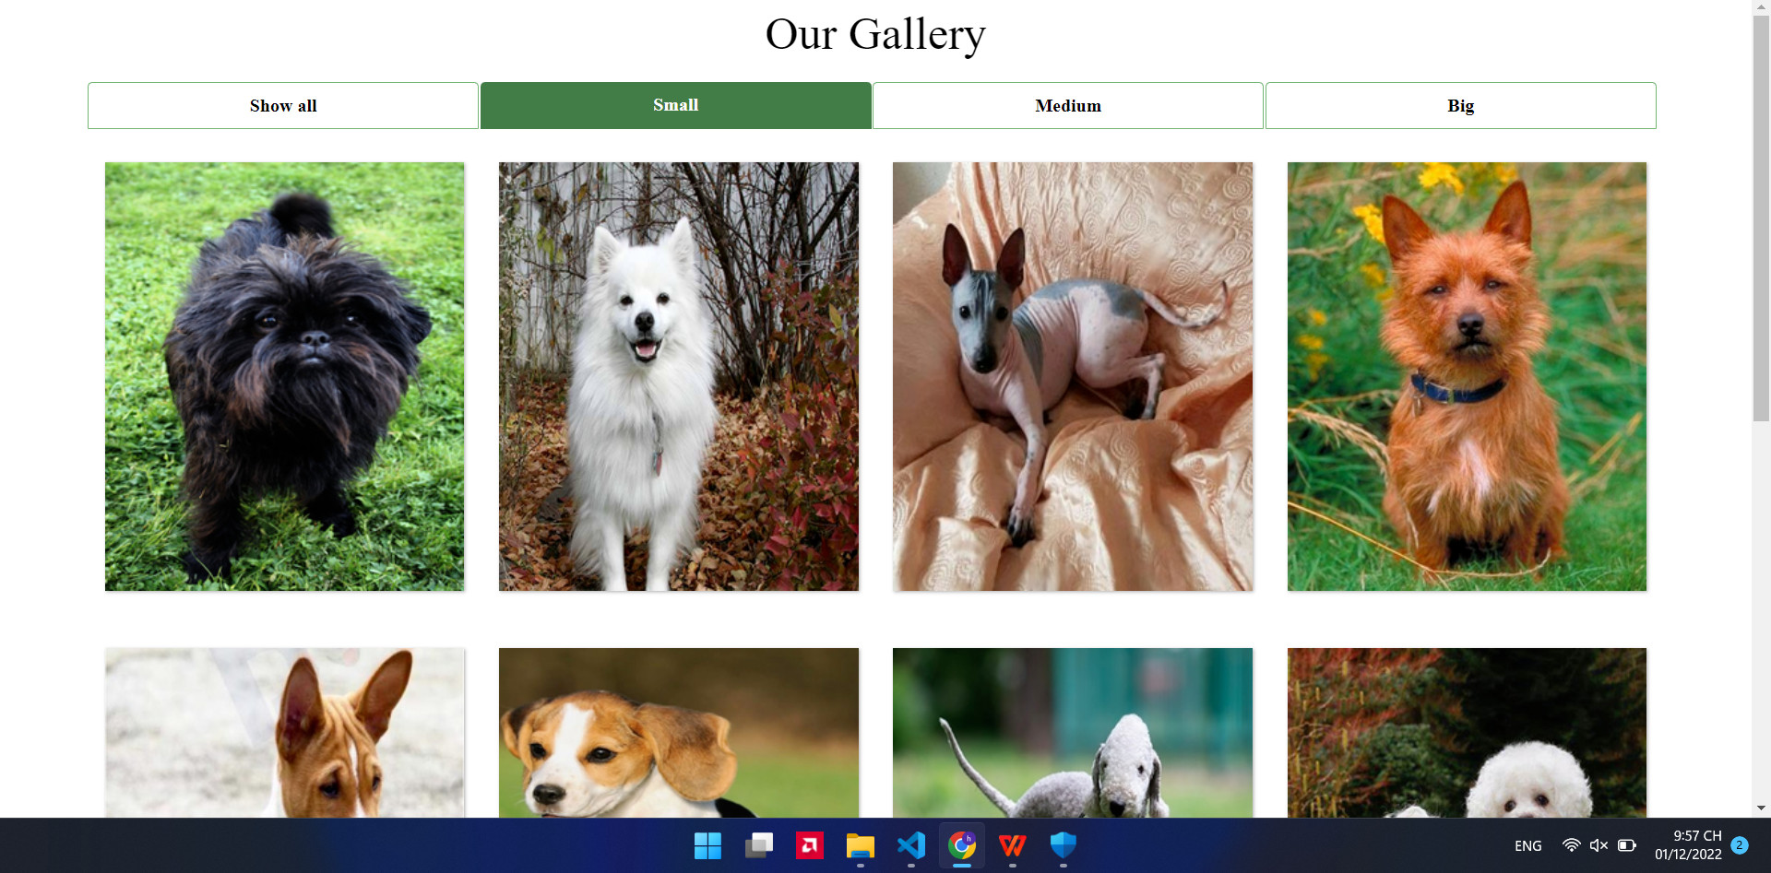

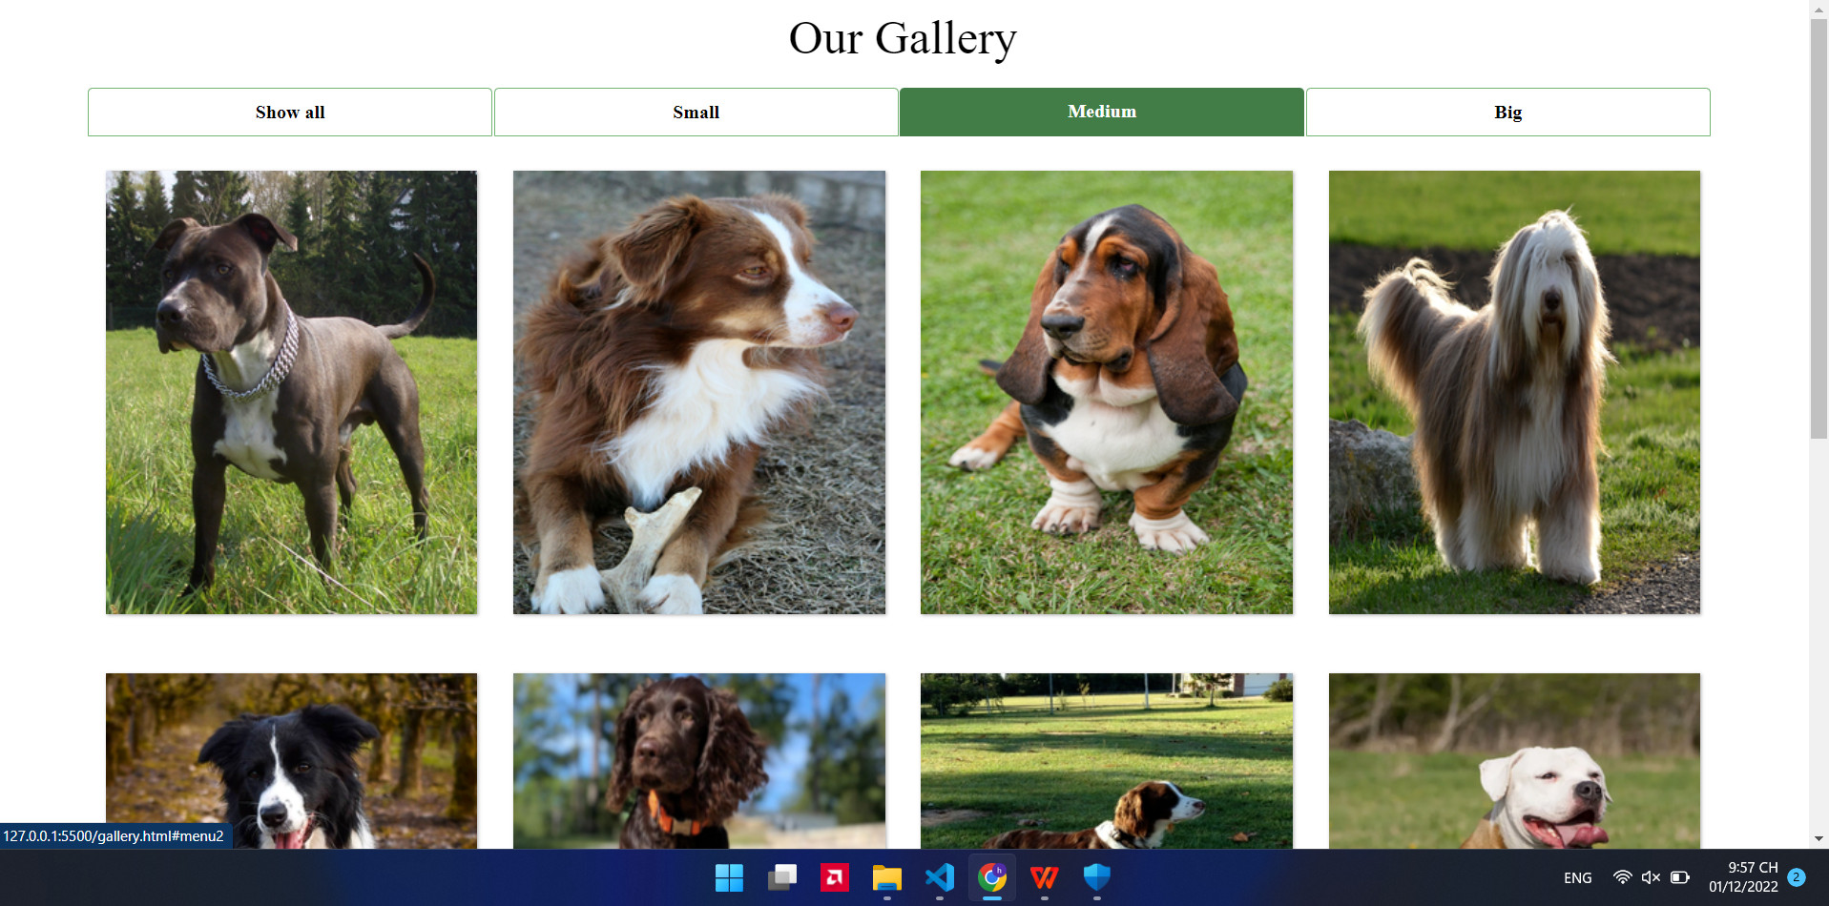

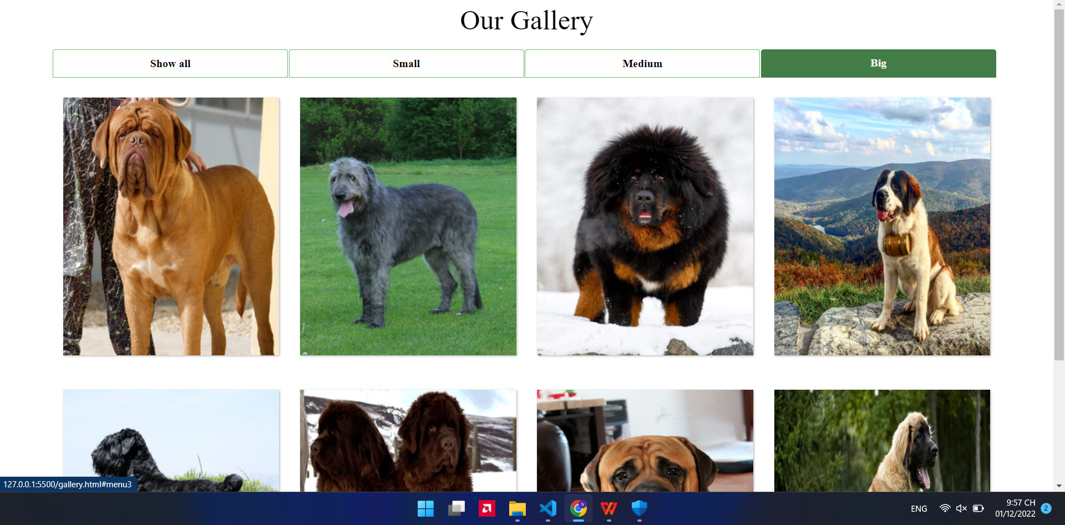

1. **Contact Us**
2. Description

This site provides a form for users to input their information to continue messages with the website’s support team. Map, Phone number, email address are available too.

1. Screen shot

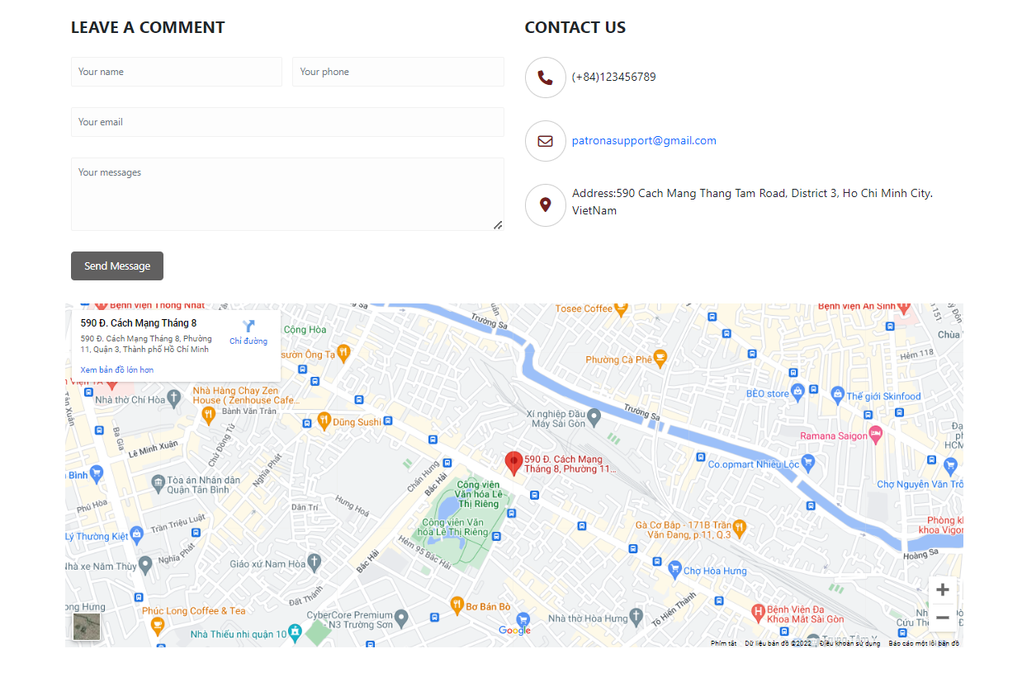

1. **About us**
2. Description

- This site contains Patrona's letter talk about her and her friendship in military.

- Some photo about team dev.

1. Screen shot

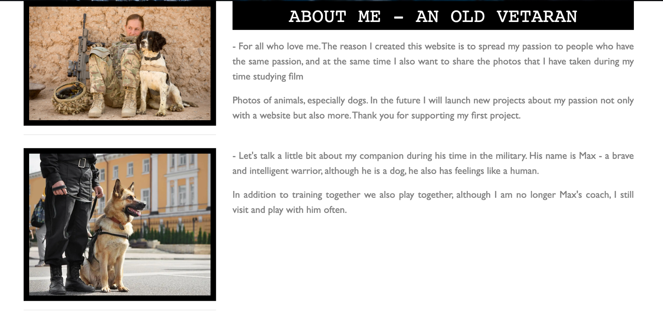



1. **FAQ**
2. Description

- There are two types of answers: static and email. Static is the available answer that we display on the website, and email is the form for the user to input their email address if they have more questions.

- Users can click on each row to display the answer.

- Routine to take care a dog is mentioned

1. Screen shot

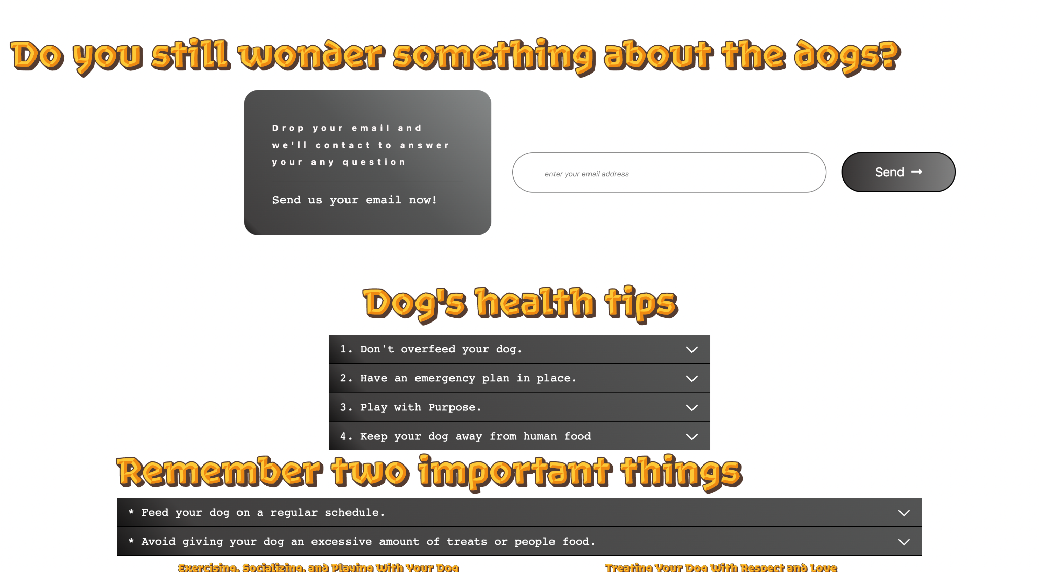

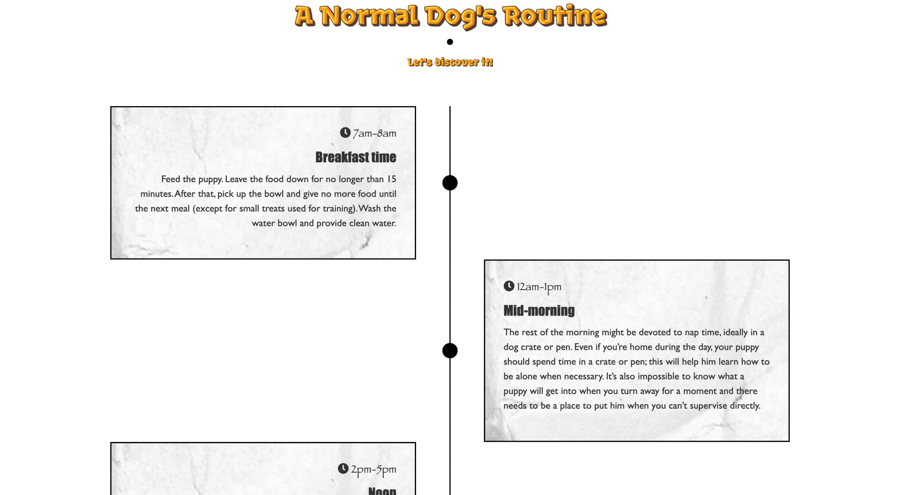

**RESPONSIVE**

The page has responsive feature for small screen device such as smartphone, tablet, etc.

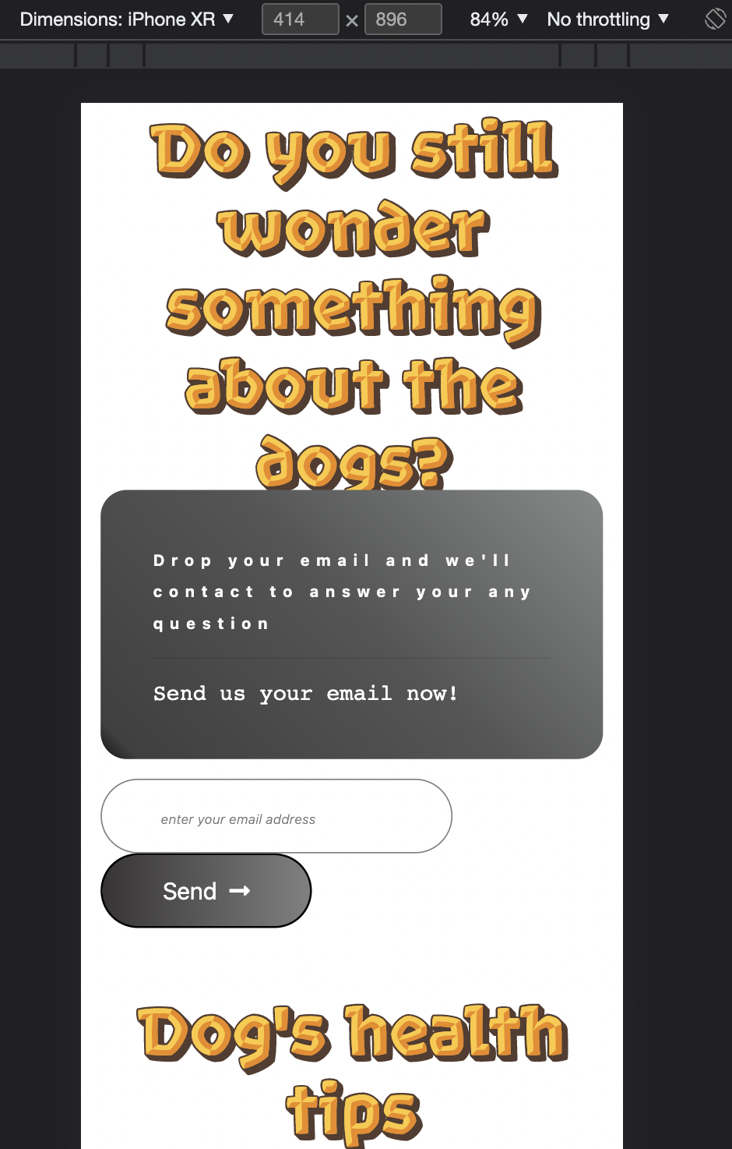

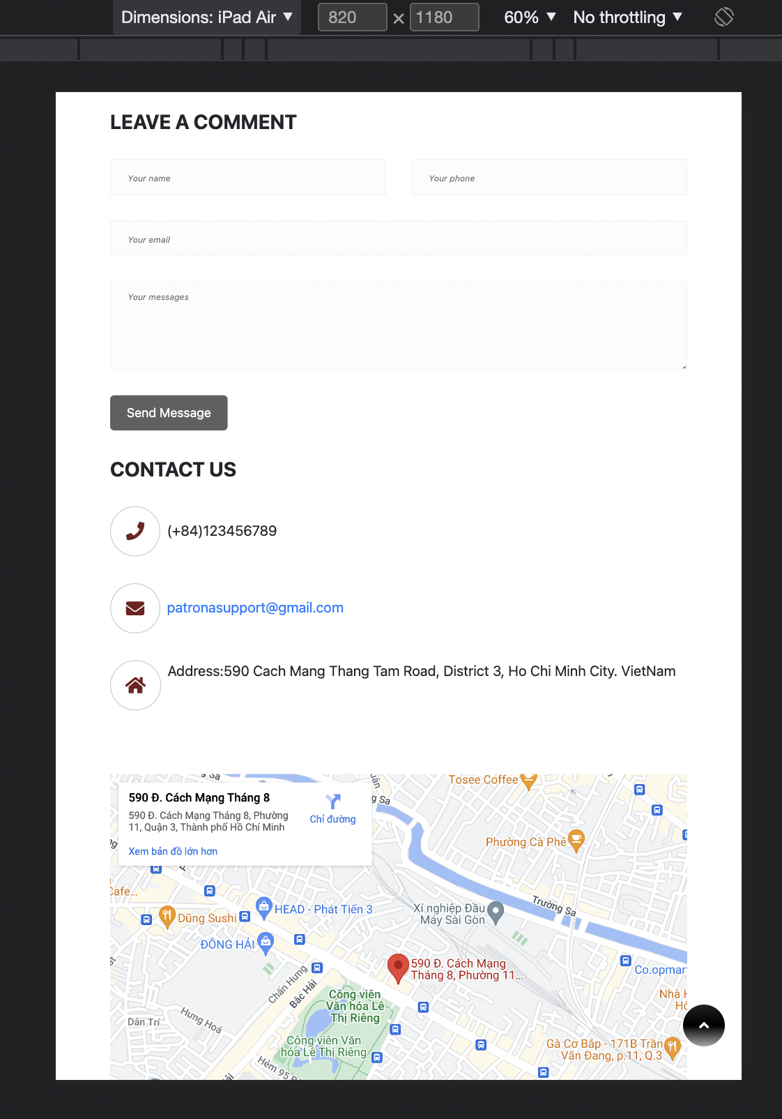

**JAVASCRIPT DESCRIPTION**

1. **Slider Javascript**
2. Description

This script is used to control and display the answers available on the FAQ site.

1. Screen shot

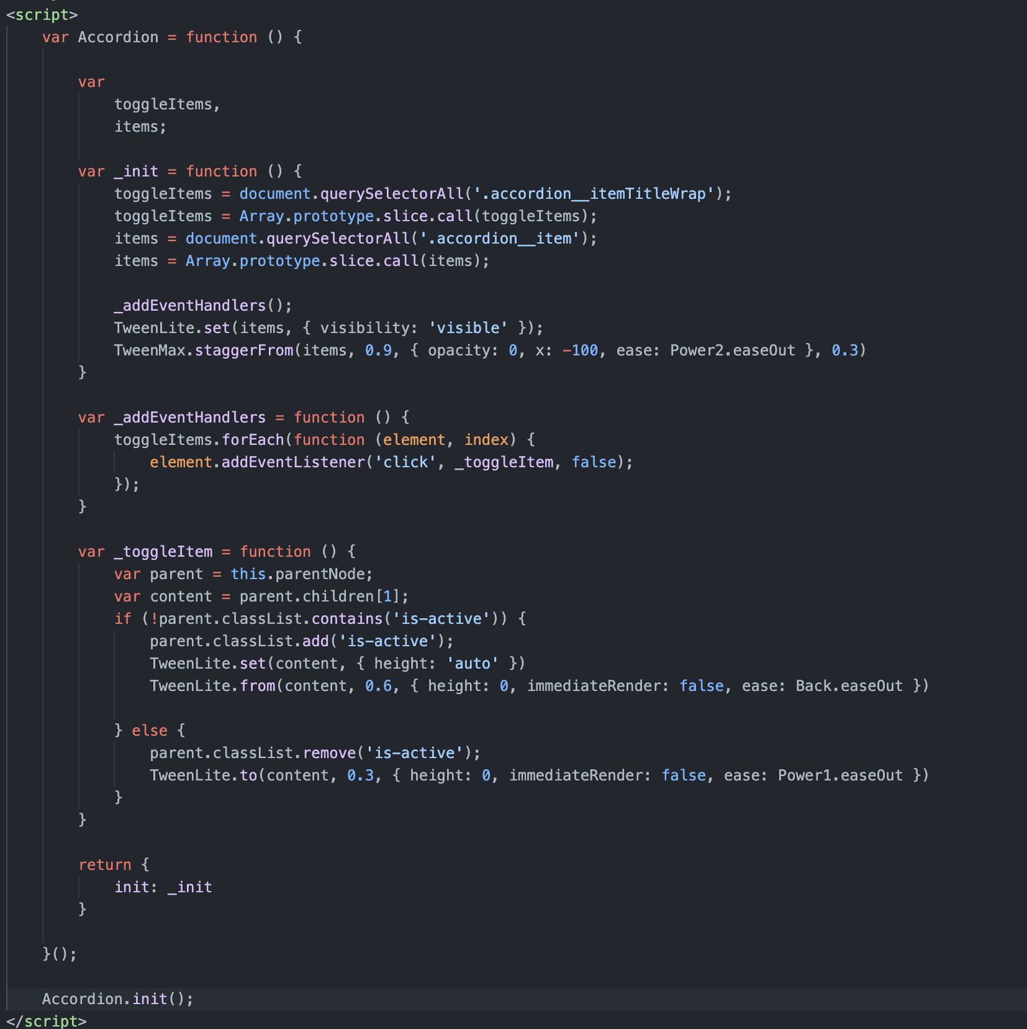

**ANGULAR DESCRIPTION**

**1.Model Angular**

1. Description

-Display a list of informations about dogs user clicking on

1. Screenshot

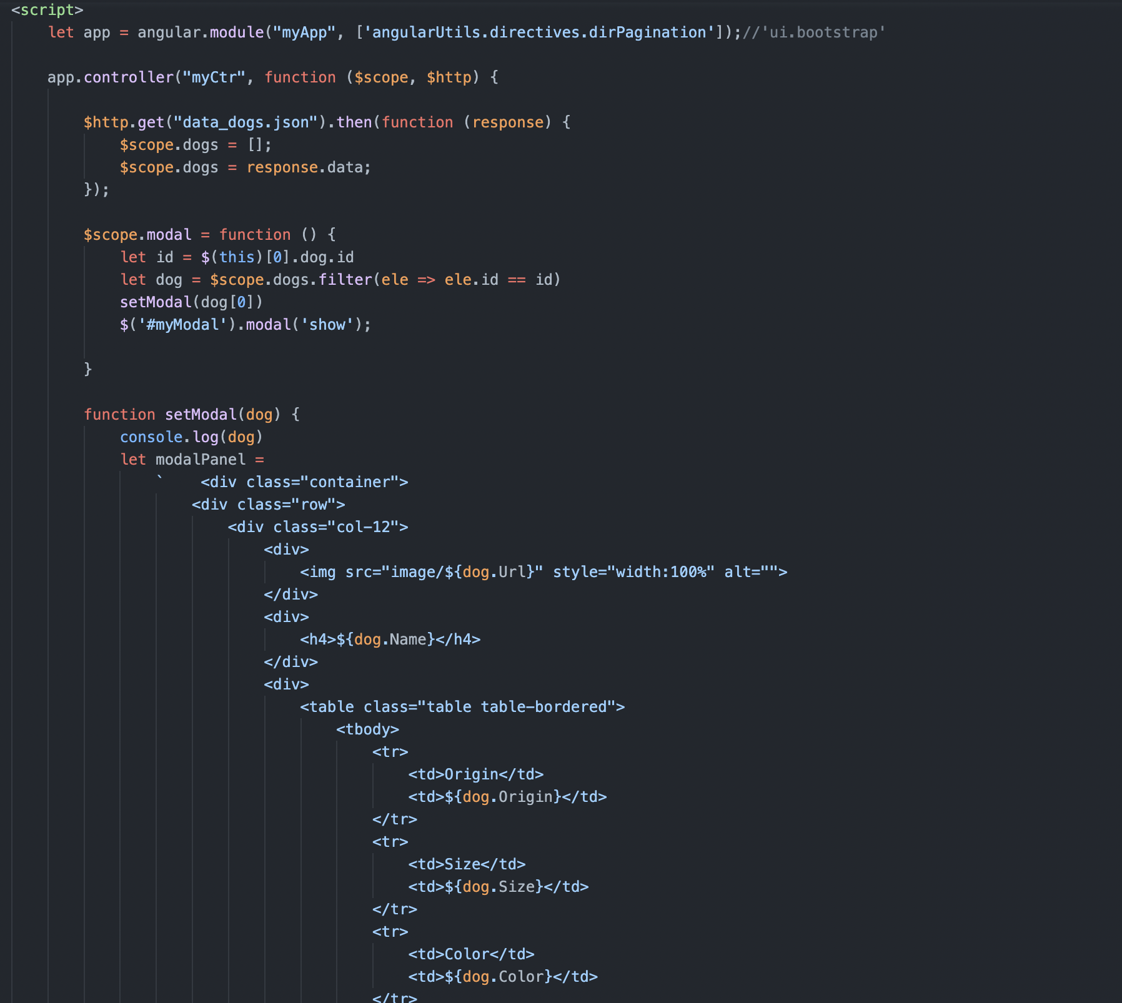

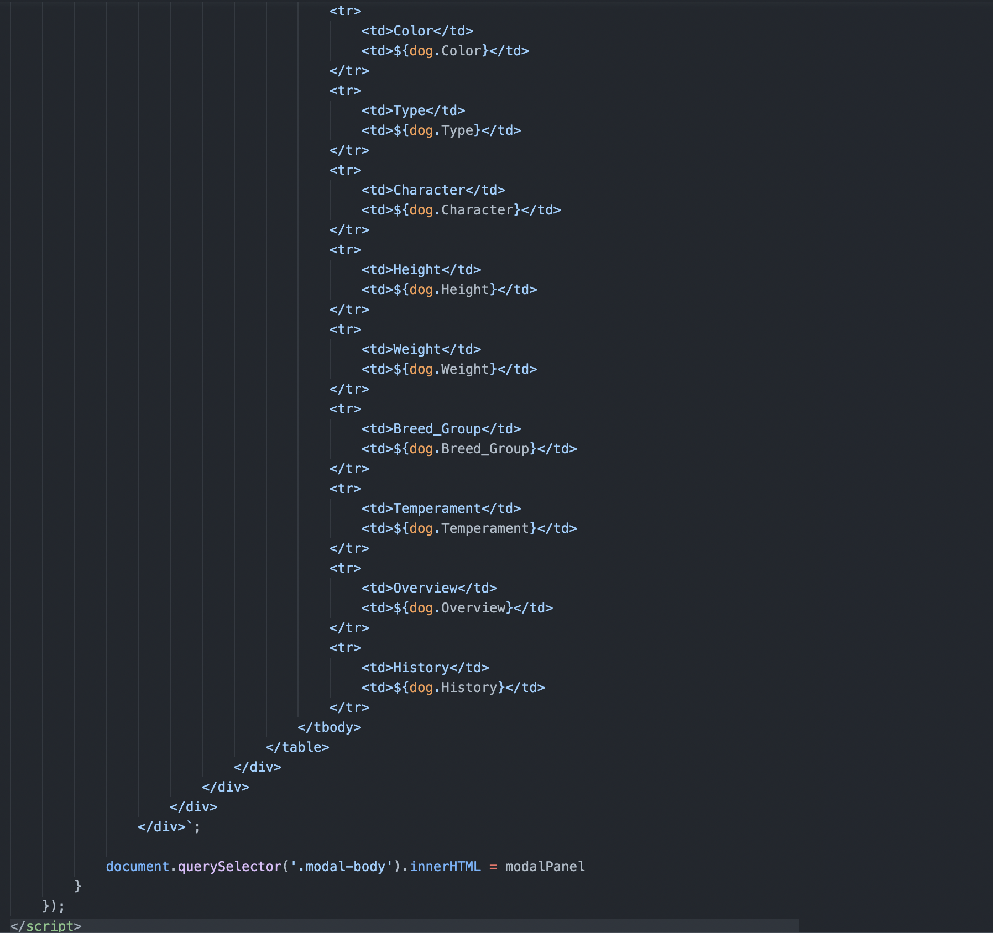

1. **Pagination Angular**
2. Description

- This angularjs use to make the pagination.

- Users can move to another page by clicking on the button.

1. Screen shot

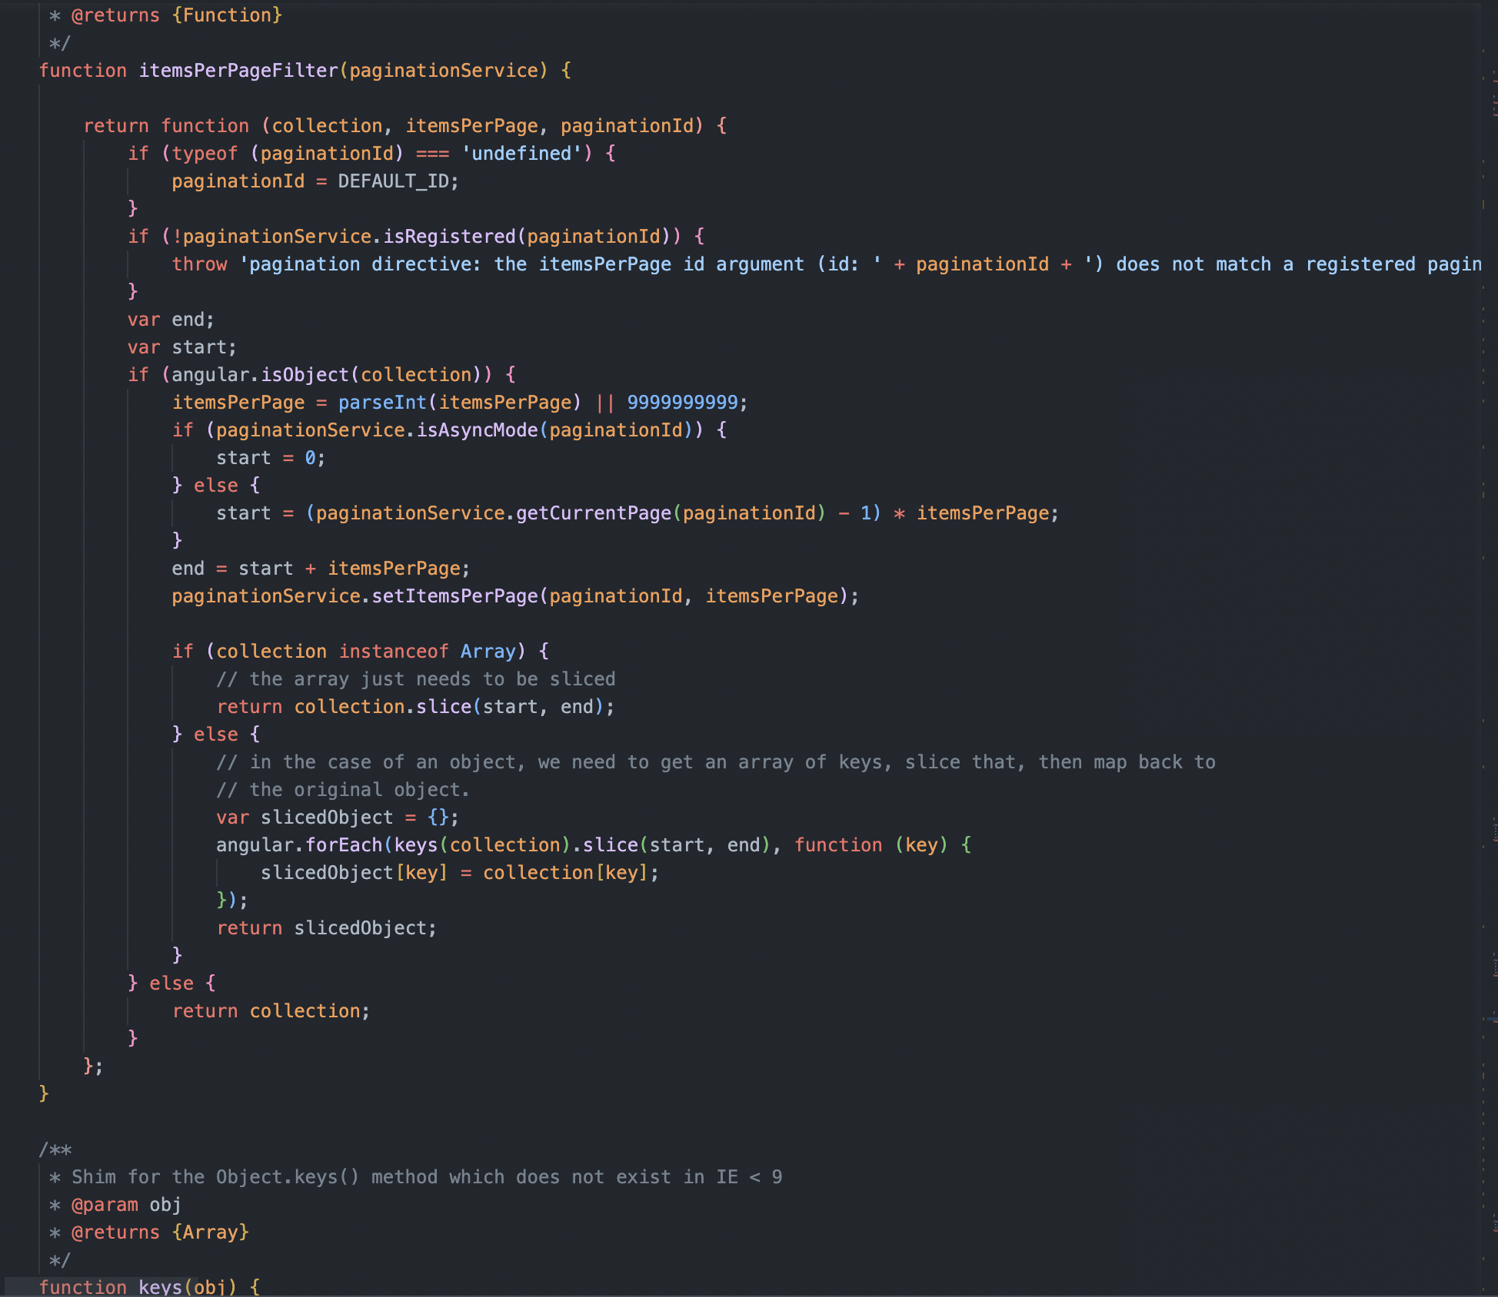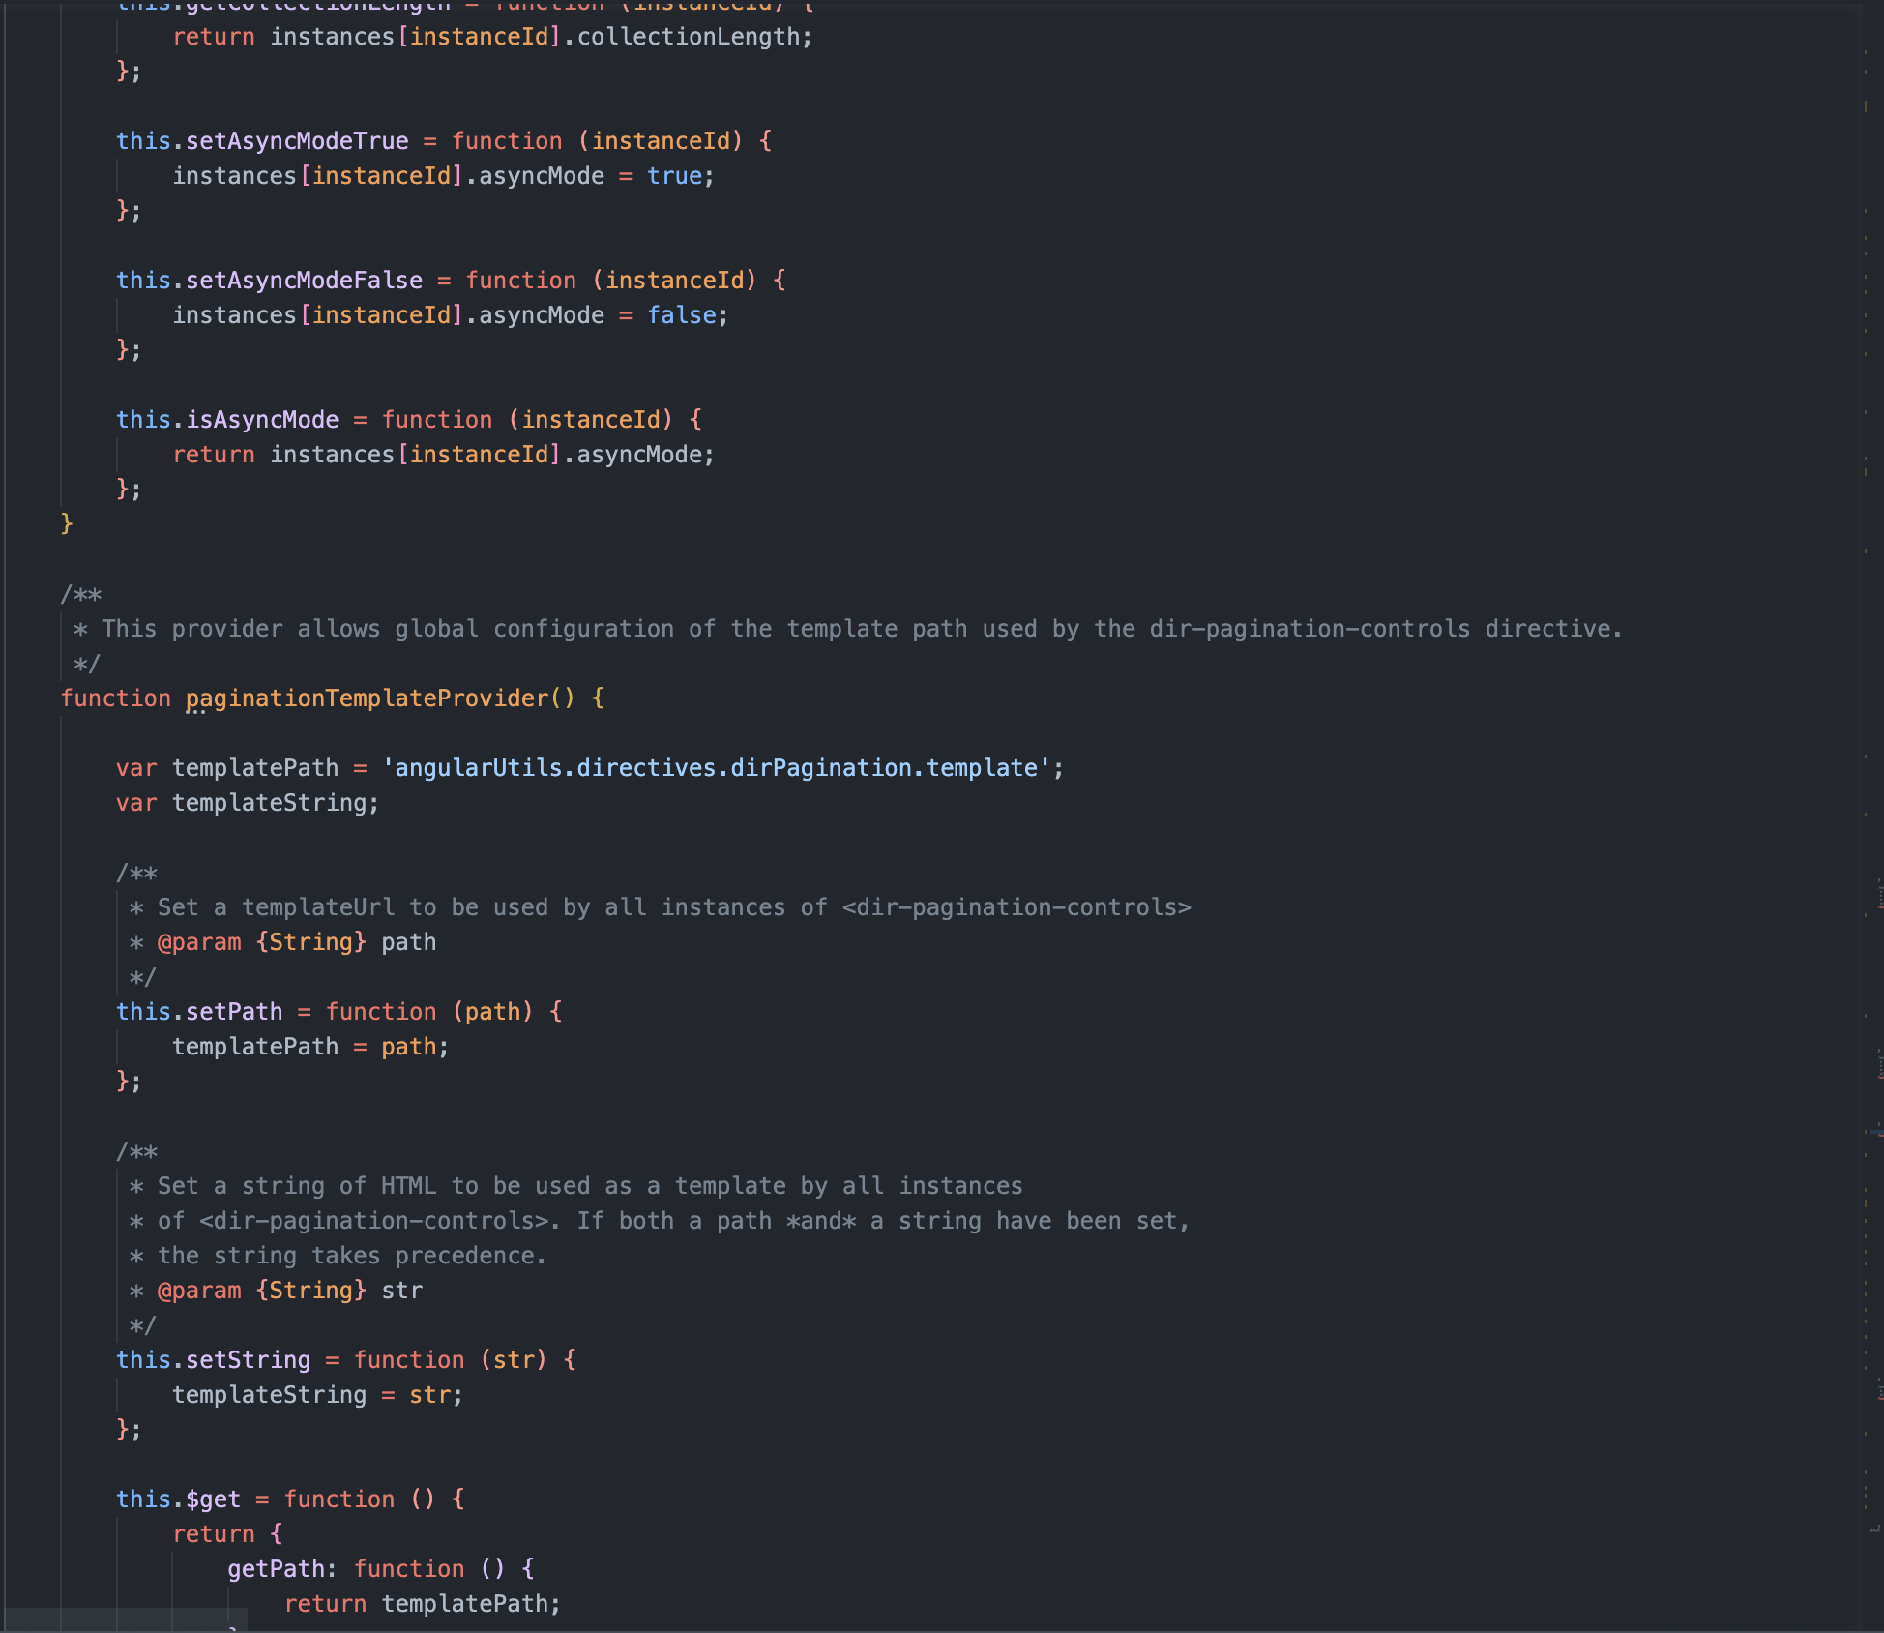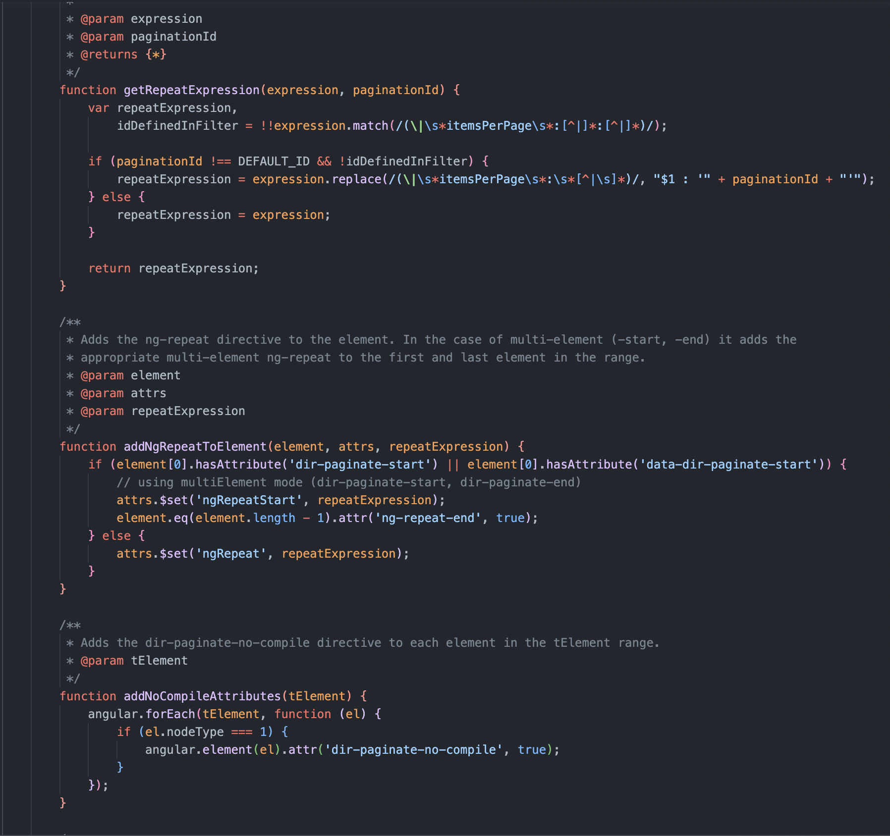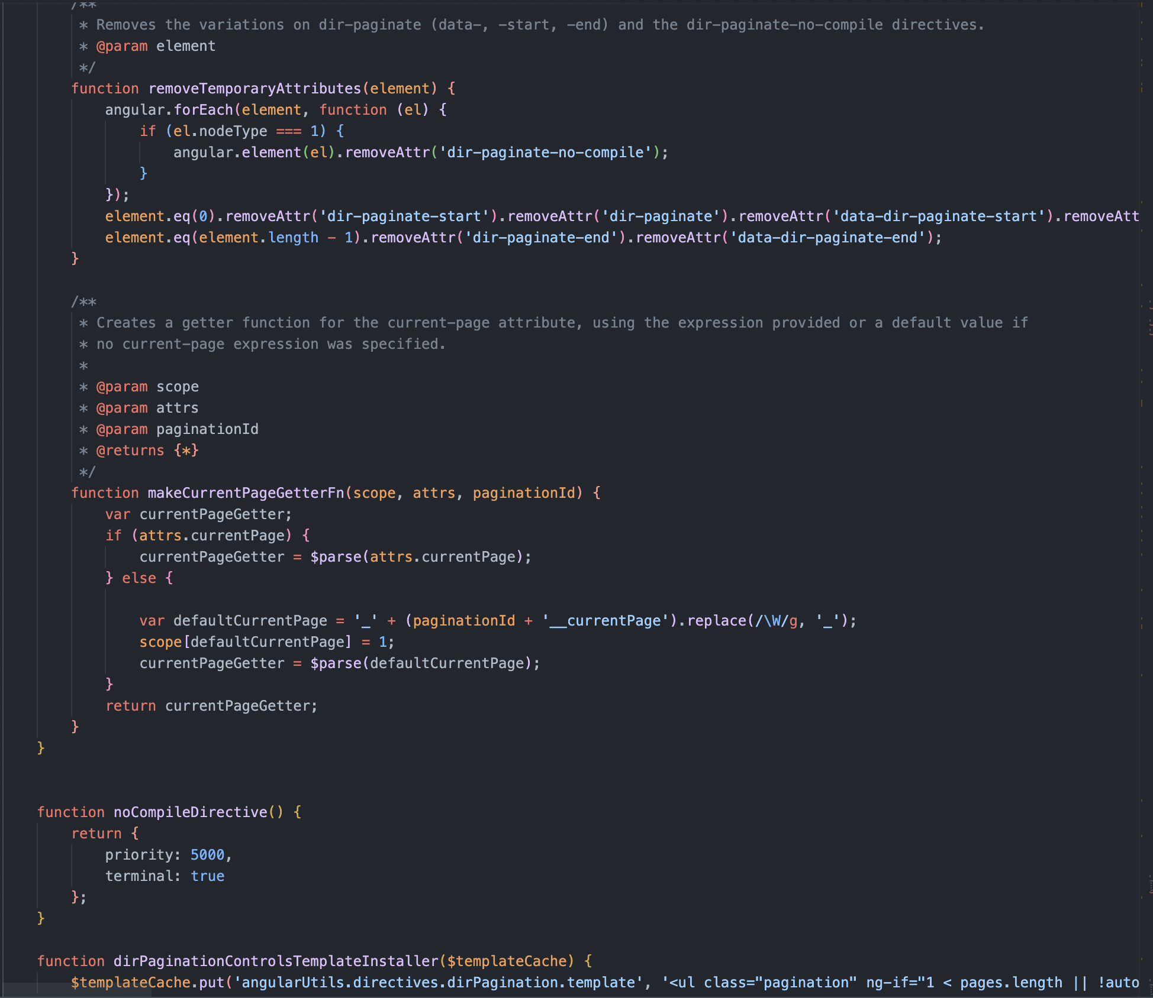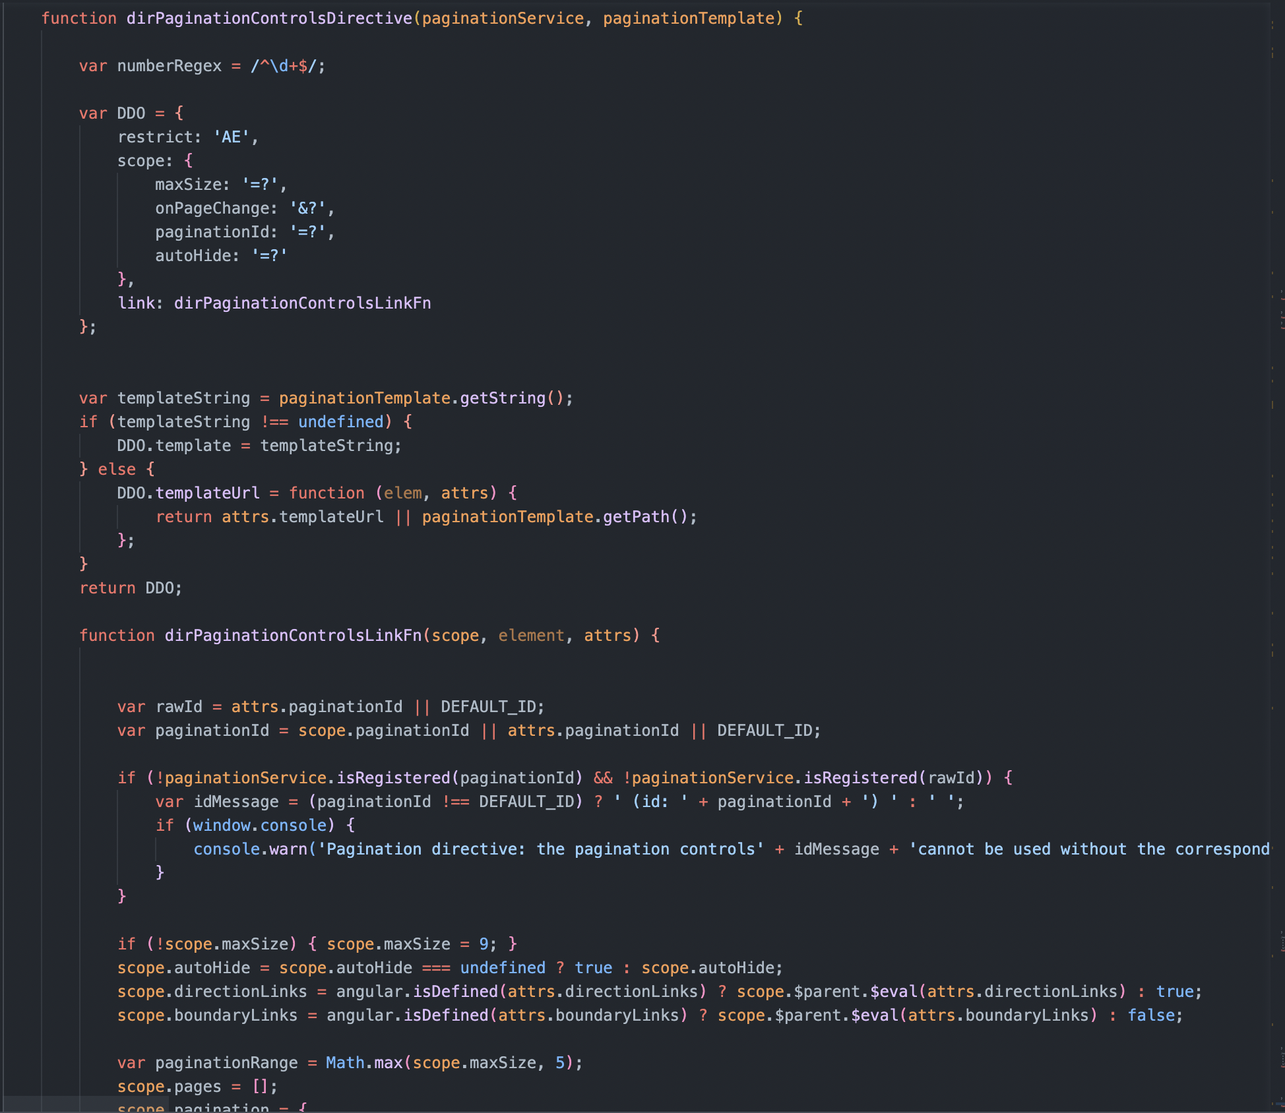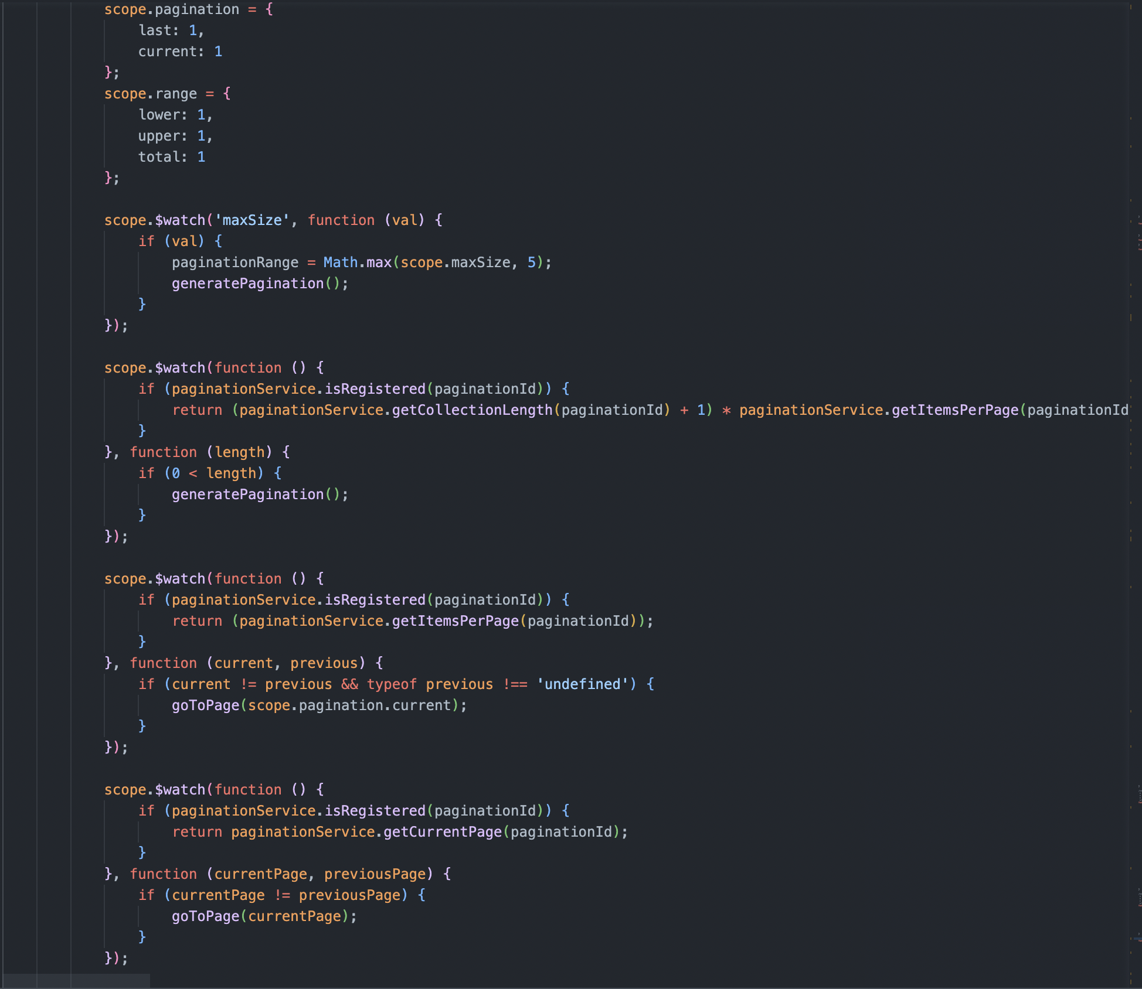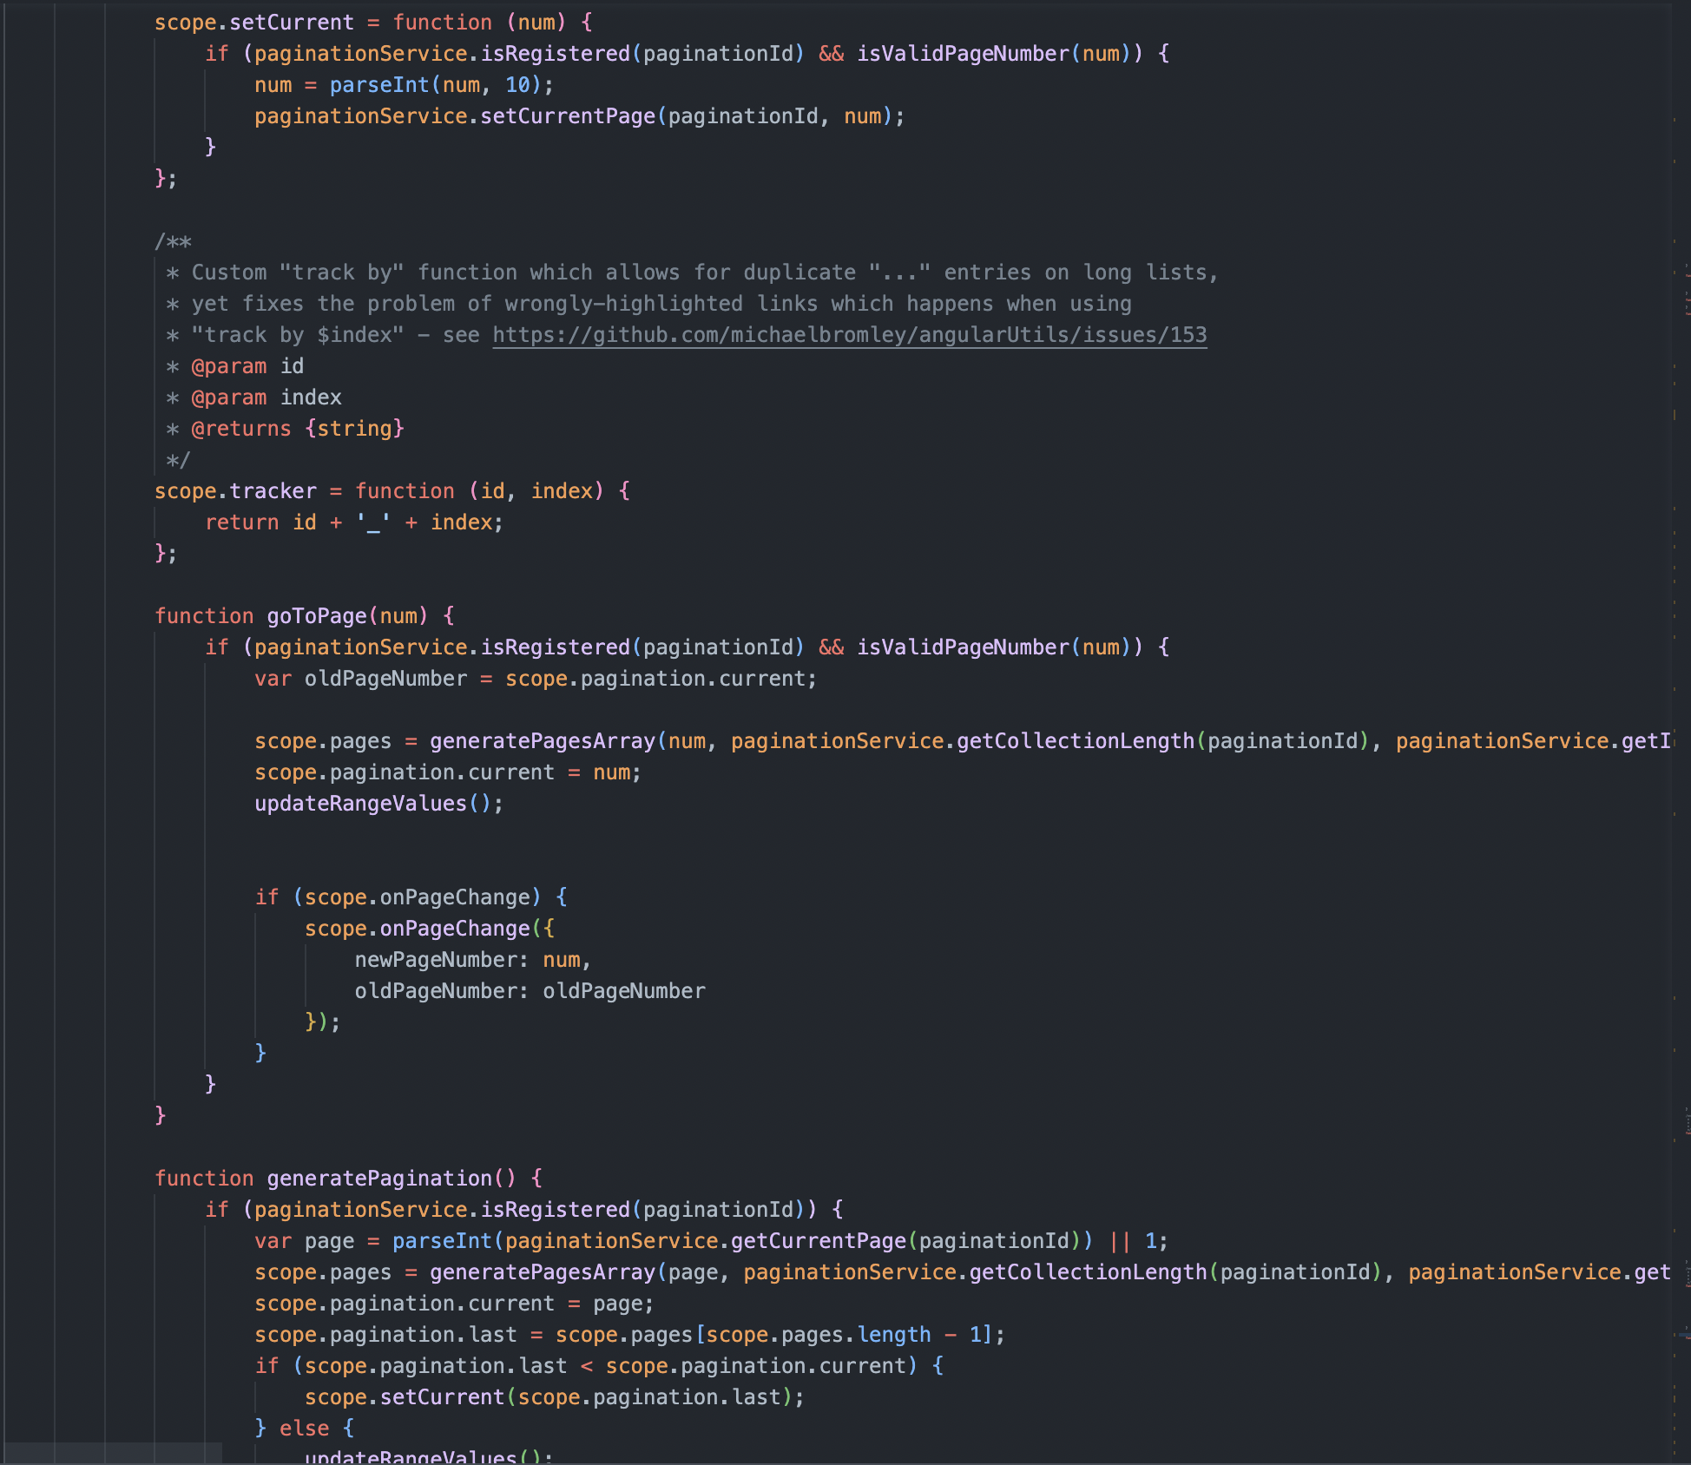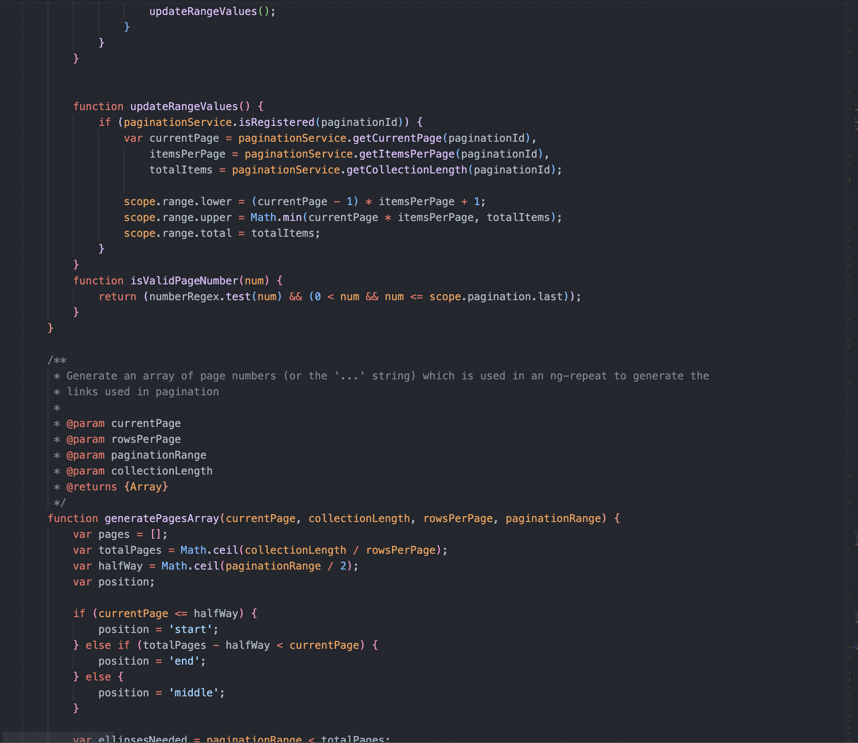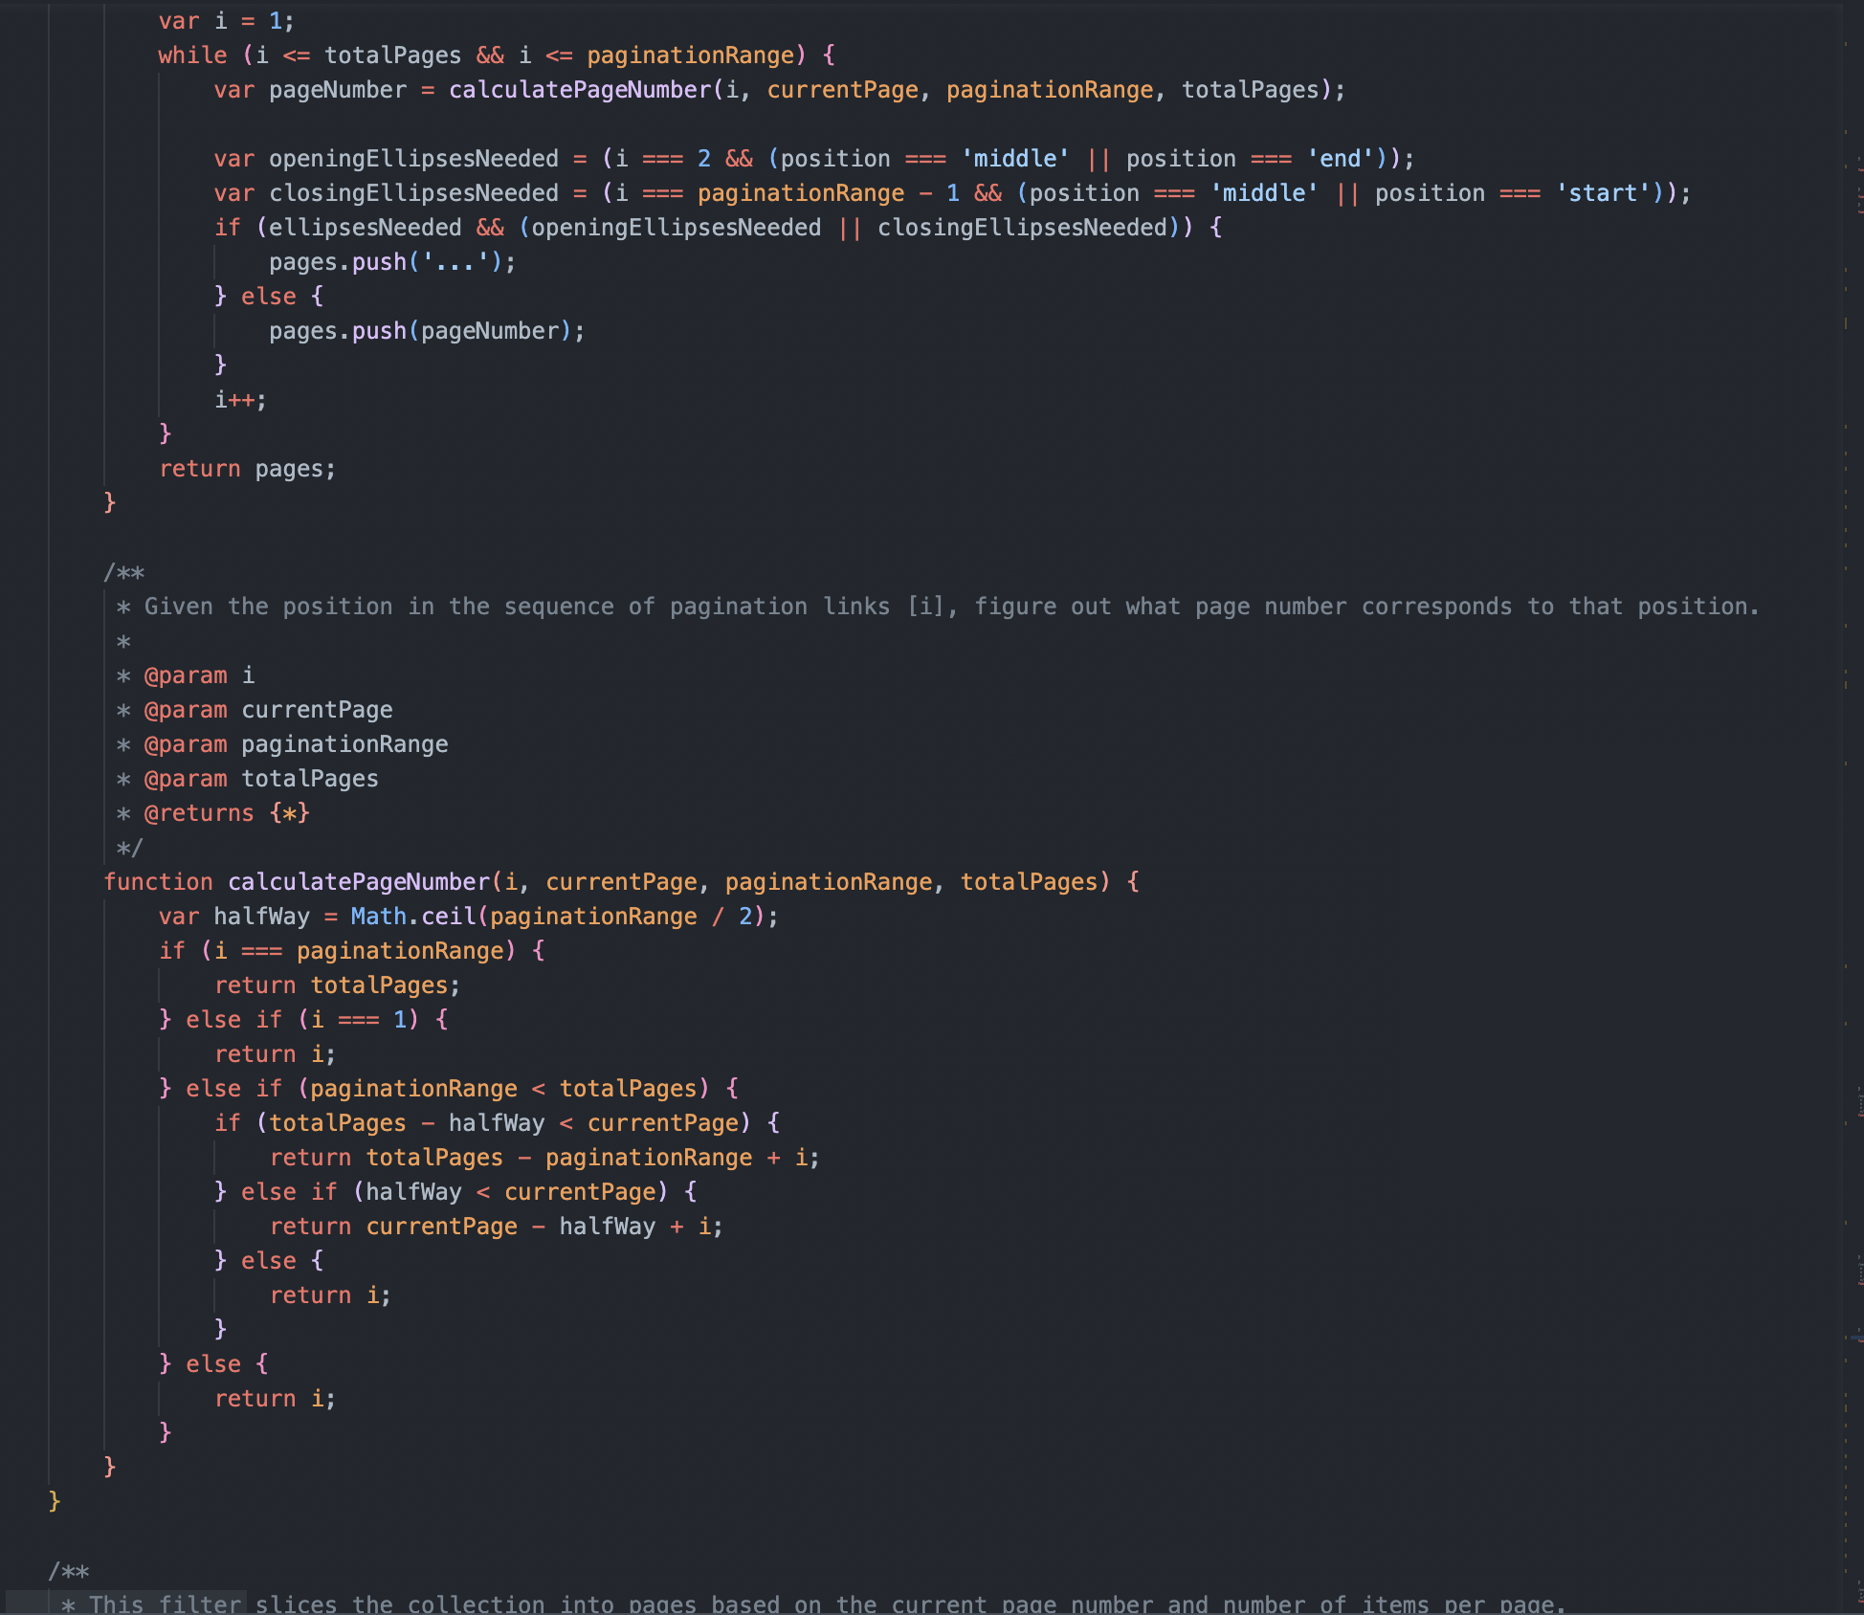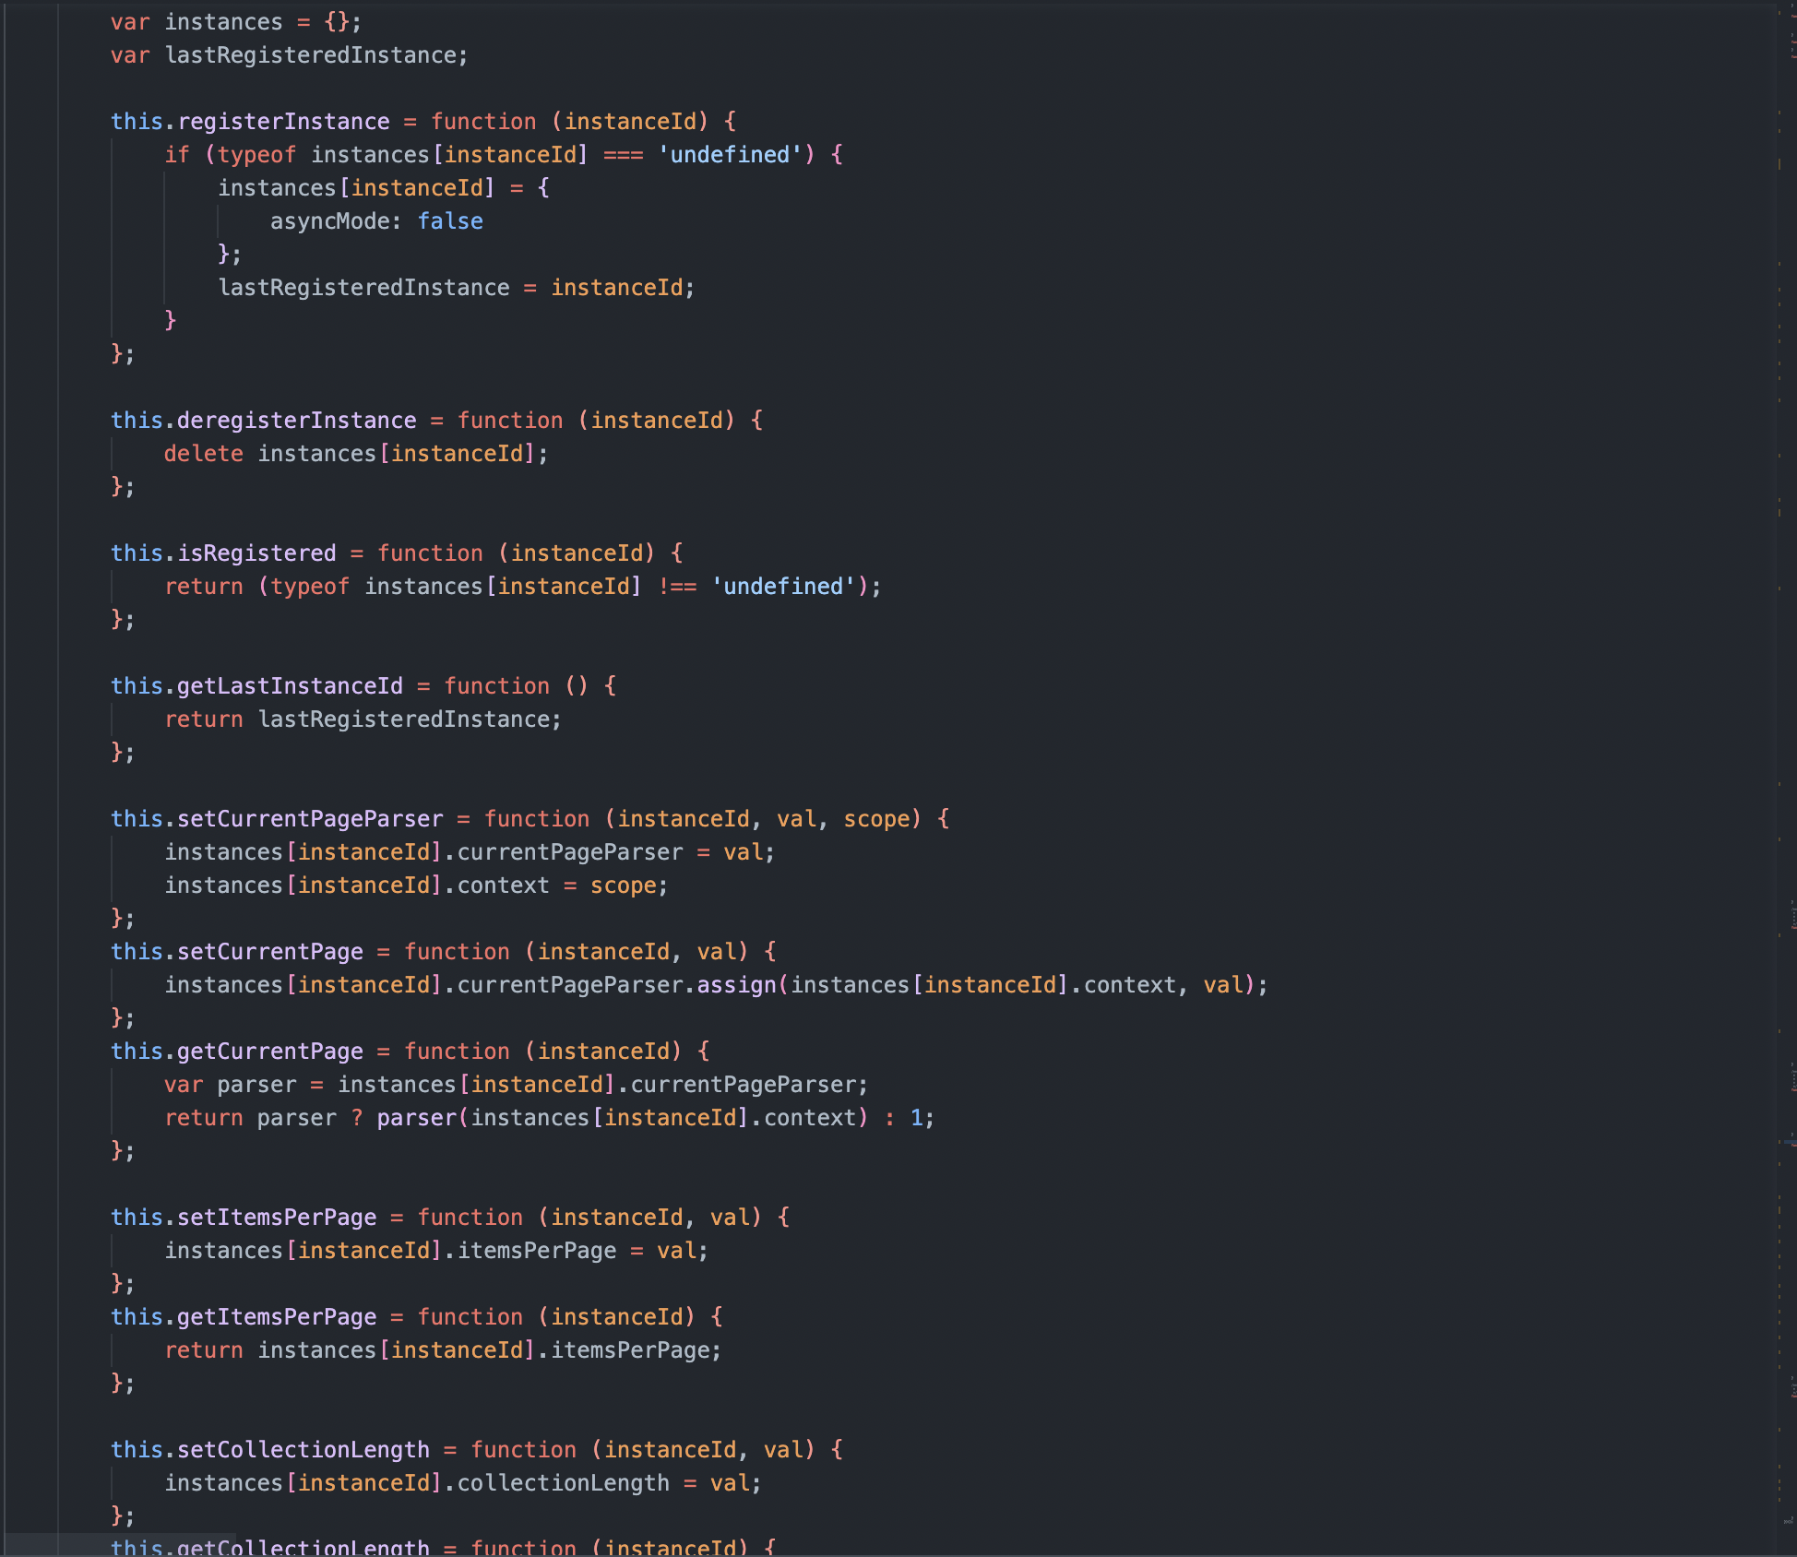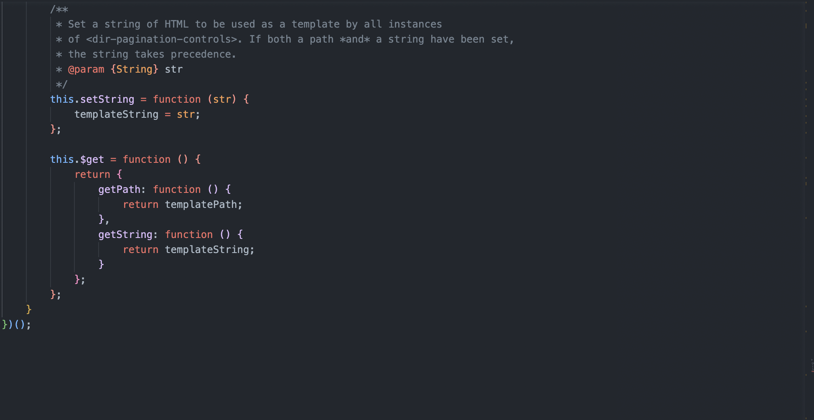

**ANGULARJS DESCRIPTION**

1. **Backtop button AngularJs**
2. Description

This AngularJs is used to move the footer of contact us page to the top

1. Sreen shot

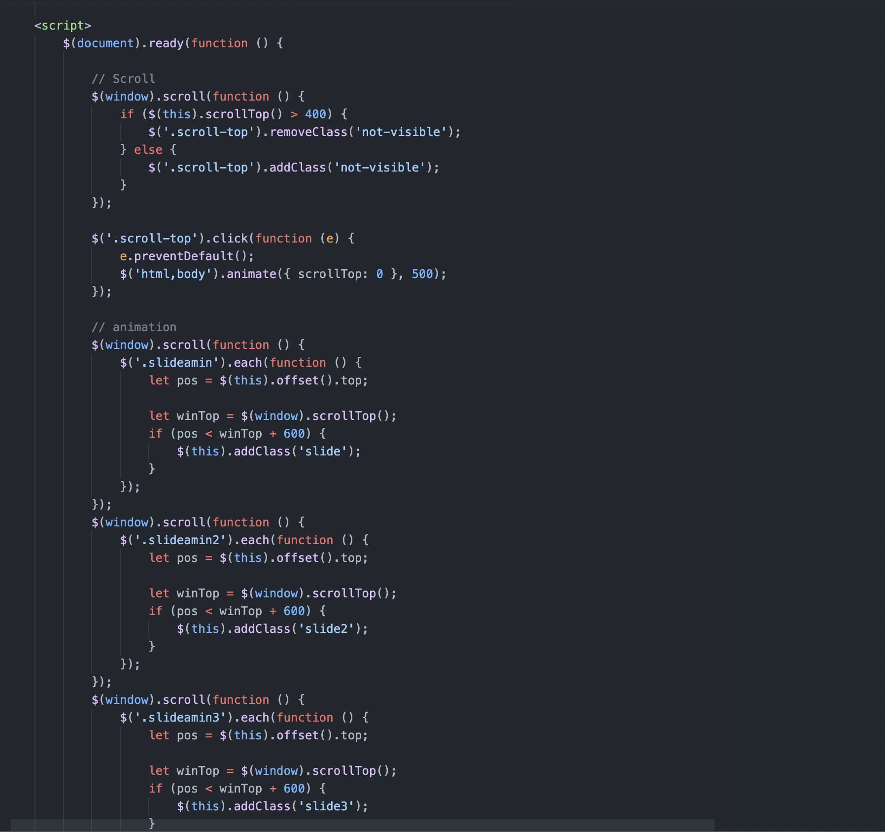

# TASK SHEET REVIEW 3

| **Project Ref. No.:**  **eP/Advertisement Portal Management**  **System/01** | | **Project Title:** | **Activity Plan Prepared By:** | **Date of Preparation of Activity Plan:** | | | |
| --- | --- | --- | --- | --- | --- | --- | --- |
| **Sr.**  **No.** | **Task** | **Actual**  **Start**  **Date** | **Actual Days** | **Team**  **Mate Names** | **Status** |
| 1 | Home | PATRONA | Tai | 18-November-22 | 2 | Tai | Completed |
| 2 | Dogs | 20-November-22 | 3 | Chien | Completed |
| 3 | Nutrition | 18-November-22 | 2 | Hao | Completed |
| 4 | Gallery | 20-November-22 | 2 | Hao | Completed |
| 5 | About Us | 18-November-22 | 2 | Khang | Completed |
| 6 | Contact Us | 20-November-22 | 2 | Chien | Completed |
| 7 | FAQ | 22-November-22 | 2 | Tai | Completed |
| 8 | Javascript,Angular | 24-November-22 | 1 | Tai | Completed |
| 9 | Jquery,AngularJS | 25-November-22 | 1 | Chien,Tai | Completed |
| 10 | Responsive |  |  | 26_November-22 | 1 | Chien,Tai,Hao | Completed |

| **Date:** | |
| --- | --- |
| Signature of Instructor:  **Ms. Le Mong Thuy** | Signature of Team Leader:  **Co Trinh Hien Tai** |